

EnergyOrb DesignTool User Manual
 | Date | 2026-01-01

About This Document
Purpose
This document describes the basic functions and operation instructions of the EnergyOrb for designing photovoltaic (PV) systems and energy storage systems (ESSs).
Statement
In this document, LUNA only refers to a specific model of Huawei Smart String ESS.
Intended Audience
This document is intended for PV plant O&M personnel and qualified electricians.
Symbol Conventions
The symbols that may be found in this document are defined as follows.
Symbol | Description
 | Indicates a hazard with a high level of risk which, if not avoided, will result in death or serious injury.
 | Indicates a hazard with a medium level of risk which, if not avoided, could result in death or serious injury.
 | Indicates a hazard with a low level of risk which, if not avoided, could result in minor or moderate injury.
Indicates a potentially hazardous situation which, if not avoided, could result in equipment damage, data loss, performance deterioration, or unanticipated results.
NOTICE is used to address practices not related to personal injury.
Supplements the important information in the main text.
NOTE is used to address information not related to personal injury, equipment damage, and environment deterioration.

Change History
Changes between document issues are cumulative. The latest document issue contains all the changes made in earlier issues.
01 (2026-01-01)
This issue is the first official release.

Contents
About This Document ii
1 System Overview 6
2 Registration and Login 7
3 Project Management 8
4 Residential Project 12
4.1 Standard Design 12
4.1.1 Entering Basic Information 12
4.1.2 Electricity Price and Consumption Settings 13
4.1.3 Performing 3D Modeling 13
4.1.3.1 Drawing the 3D Model 14
4.1.3.2 Importing the Model 17
4.1.4 PV Module Layout 18
4.1.5 Electrical Design 20
4.1.6 Economic Analysis 22
4.1.7 Generating a Report 22
4.2 Quick Design 27
4.2.1 Entering Basic Information 27
4.2.2 Plant Design 27
4.2.3 Generating a Report 28
5 Commercial and Industrial Project 31
5.1 Standard Design 31
5.1.1 Entering Basic Information 31
5.1.2 Electricity Price & Consumption Settings 32
5.1.3 Performing 3D Modeling 33
5.1.3.1 Drawing the 3D Model 33
5.1.3.2 Importing the Model 37
5.1.4 PV Module Layout 38
5.1.5 Electrical Design 41
5.1.6 ESS Design 42
5.1.7 Economic Analysis 44
5.1.8 Generating a Report 45
5.2 Quick Design 49
5.2.1 Entering Basic Information 49
5.2.2 Plant Design 49
5.2.3 Generating a Report 50
5.3 Capacity Design 52
5.3.1 Capacity Design (Old Version) 52
5.3.1.1 Entering Basic Information 52
5.3.1.2 Electricity Price and Consumption Settings 53
5.3.1.3 Plan Settings 54
5.3.1.4 Economic Settings 57
5.3.1.5 Generating a Report 58
5.3.2 Capacity Design (New Version) 59
5.3.2.1 Basic Information 59
5.3.2.2 Electricity Price & Consumption 60
5.3.2.3 System & Cost 62
5.3.2.4 Report 64
6 More Settings 66
6.1 Custom PV Modules 66
6.2 Setting Frequently Used PV Modules 69
6.3 Genset Configuration 69
6.4 Economic Settings 70
6.5 Report Cover Settings 70
7 FAQs 71
7.1 How Do I Set the Time-of-Use Electricity Prices? 71
7.2 How Do I Generate an Energy Consumption Model by Importing Data? 72
7.3 What Shall I Do When Operations on the PV Module Layout Fail? 74
7.4 How Do I Import Meteorological Data? 75
8 Reference Information 77
8.1 Residential Solution Overview 77
8.2 Report Parameters 96
8.3 Acronyms and Abbreviations 100

System Overview
This system is used to assist in designing PV systems, ESSs, and PV+ESS systems. It provides information such as the PV or ESS installation effect drawing, devices, price list, total quotation, and revenue for the PV owner, and intuitively displays the advantages and benefits of a PV design scheme.
Client Configuration
Use a PC that meets the following requirements to access the system with better experience:
Capacity | Resolution | Browser | CPU | Memory | Graphics Card
< 10 MW | Optimal resolution: 1920 x 1080 pixels | Chrome 79, Firefox ESR 68, or later is recommended. | / | / | /
10 MW | Optimal resolution: 1920 x 1080 pixels | Chrome 79, Firefox ESR 68, or later is recommended. | i7 3.2+ GHz | 8+ GB | 4+ GB GPU memory (or integrated graphics card)

Registration and Login
Registering an Account

If you already have a installer account, you can use this account to access the DesignTool without repeated registration. An owner account cannot be used to access the DesignTool. You need to register a system account.
- In the address bar of a browser, enter a domain name in the following table, and press Enter.
- Europe: https://designer.energyorb.com
- Click Installer Registration and complete the registration as prompted.
System Login
- In the address bar of a browser, enter a domain name in the following table, and press Enter to access the login page.
- Europe: https://designer.energyorb.com
- Specify the username and password, and tap Login.
System Logout
In the upper right corner of the system page, click and select Log Out.

Project Management
Creating a Project
You need to create a project to design a plant in the residential and C&I scenarios.
Scenario | Project Type | Description
Residential | Standard Design | Applies to small-scale residential scenarios. 3D modeling is used to simulate the real environment and assist in PV plant system design. ESSs are supported. The maximum installed capacity is 100 kW. For details, see 4.1 Standard Design.
Residential | Quick Design | Applies to small-scale residential scenarios. Reports can be quickly generated after plant information is configured. ESSs are supported. The maximum installed capacity is 100 kW. For details, see 4.2 Quick Design.
C&I | Standard Design | Applies to large-scale C&I scenarios. 3D modeling is used to simulate the real environment and assist in PV plant system design. ESSs are supported. The maximum installed capacity is 10 MW. For details, see 5.1 Standard Design.
C&I | Quick Design | Applies to large-scale C&I scenarios. Reports can be quickly generated after plant information is configured. ESSs are not supported. The maximum installed capacity is 1.5 MW. For details, see 5.2 Quick Design.
C&I | Capacity Design | Applies to large-scale C&I ESS scenarios to calculate the ESS capacity and analyze benefits. For details, see 5.3 Capacity Design.

Managing a Project
- Copying a project
In the project list, click in the Operation column.
When a project is copied, all schemes of the project are copied.
- Sharing a project
Select a project from the project list and click in the Operation column. In the dialog box that is displayed, enter a username and click Add to share the project with the corresponding user.
- The project owner can set the permission of a member who shares the project to Read-Only or Edit.
- To remove a member, move the cursor to the member and click .
- If a project report has been generated and the sharing permission is valid, the report can be shared by the static report link.
- If the message This report has expired is displayed, the sharing permission of the project report has expired. If you want to share a report, you need to reset the validity period on the Report page.
- If the message This report has been closed is displayed, the sharing permission of the project report is disabled. If you want to share a report, enable Share on the Report page.
- Locking a project
Project locking is supported in standard design. Open a project and click in the upper right corner to lock the project. When the project is locked, you can only view the project but cannot edit it. When the project is unlocked, you can edit it. A locked project cannot be edited. Subsequent changes in design specifications do not apply to the project until it is unlocked.
- Deleting a project
Select a project from the project list, click , and click Delete to delete the project.
- Create a plant on the Management System or App.
For a project where PV modules have been arranged, click in the upper right corner of the project, enter related information, and create a plant on the Management System or the app. The following information will be synchronized to the Management System or the app.
- Plant creation is supported only in standard design projects.
- The plant creation button is not displayed on the first three steps.
- Plant creation is not supported in the project with a created plant.
Managing a Scheme
You can add, compare, rename, delete, and set a scheme as the primary scheme only for a Standard Design project.
- Adding a scheme
Method 1:
  - Select a project from the project list, click in the Operation column, and click New Scheme.
  - Enter the scheme name, click OK, and perform steps 4 to 6/7 based on the site requirements.
After a scheme is added, the settings in steps 1 to 3 are shared with other schemes. If you modify the settings, the existing schemes will be affected. If you select Reuse Existing Scheme, the settings in all steps of the selected scheme are copied.
Method 2:
Select a project. In steps 4 to 7/8, click in the upper left corner, move the cursor to the corresponding scheme, and choose Copy. After a scheme is copied, the settings in steps 1 to 3 are shared with other schemes. You can modify the settings as required. If you modify the settings, the existing schemes will be affected.
A project supports a maximum of five schemes.
- Renaming a scheme
Method 1: In the project list, click in the Project Image column and click in the Operation column.
Method 2: Select a project. In steps 4 to 7/8, click in the upper left corner, move the cursor to the corresponding scheme, and choose Rename.
- Deleting a scheme
Method 1: In the project list, click in the Project Image column and click in the Operation column.
Method 2: Select a project. In steps 4 to 7/8, click in the upper left corner, move the cursor to the corresponding scheme, and choose Delete.
- Setting the current scheme as the main scheme
Select a project. In steps 4 to 7/8, click in the upper left corner, move the cursor to the corresponding scheme, and choose Set as Primary Scheme. The scheme is set as the primary scheme. After you enter the project again, the scheme is displayed by default.
- If no primary scheme is set, the first scheme is the primary scheme by default.
- If a plant has been created for the project on the Management System or the App, the plant creation scheme is set as the primary scheme.
- Comparing schemes
You can compare and analyze different schemes of the same project to display the optimal design scheme for the owner. The schemes can be compared and analyzed only after a report is generated.
  - In the project list, select the schemes to be compared, click in the Operation column, and choose Compare and Analyze.
  - On the Compare and Analyze page, you can view the scheme comparison in terms of basic information, energy yield, devices, and economic analysis.
A maximum of three different schemes can be compared at the same time.
Getting More Help
In the upper right corner of the system page, click  to open the help panel and obtain more operation guides.

Residential Project

Standard Design
After logging in to system, click Standard Design in the Residential scenario, and then design the project and fill in the project information as prompted. Then, the project is created and a report is generated.
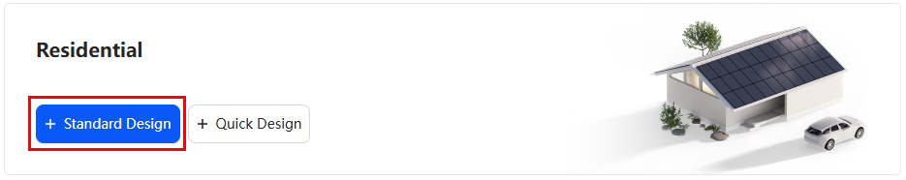
The process of creating a standard design project and generating a report is as follows.

Entering Basic Information
The basic information includes the PV plant location, weather station, and grid parameters.
- Enter the project name, and set basic information such as the location of the PV plant, weather station, and power grid parameters based on the site requirements.
If no weather stations provided by the system meet the requirements, click  to upload the meteorological data. For details about the upload requirements, see 7.4 How Do I Import Meteorological Data?
- Frame the location where the PV plant is to be installed.
- Method 1: Hold down on the map, move the cursor to the location where the PV plant is to be installed, and adjust the frame size to ensure that the location is completely framed.
- Method 2: Hold down any place on the map, move the cursor to the location where the PV plant is to be installed, and adjust the frame size to ensure that the location is completely framed.
- Click Next to save the settings.

Electricity Price and Consumption Settings
After the electricity prices and loads are set, the system recommends an appropriate ESS capacity based on the maximum self-consumption rate.
Electricity Price Settings
To ensure accurate benefit calculation, set related parameters in Electricity Price Settings as required.
- Click Set and select a currency unit as required.
- Set Feed-in Tariff.
- Set Purchase Price.
- Set Electricity Price Growth Rate.
If a price template has been configured in the Management System, you can select User-Defined Input or Template Input as required.
If no price templates have been configured in the Management System, you can set Purchase Price based on the actual situation.
Consumption Settings
- Creating an energy consumption model through model generation
  - Set Type to Generate Model.
  - Set Annual Energy Consumption and Monthly Energy Consumption as required.
  - Set Workday Model and Weekend Model as required. The system displays the daily load curve based on Workday Model and Weekend Model.
  - Optional: If the preconfigured models cannot meet your requirements, set Workday Model or Weekend Model to Custom and click to edit the model.
  - Click Next to save the current scheme.
- Creating an energy consumption model by importing data
  - Set Type to Data Import.
  - Click Download Template, enter the load data in the template as required, and save the template. For details, see 7.2 How Do I Generate an Energy Consumption Model by Importing Data?
  - Click Add File, and select and upload the saved template.
  - Click Next to save the current scheme.
If no load is connected, set Annual Energy Consumption to 0.

Performing 3D Modeling
After you specify the location, the system automatically generates a rectangle area. In this area, you can draw buildings or import building models to draw rooftops to facilitate PV module arrangement and electrical design. If you encounter any difficulties during the operation, click User Guide in the lower left corner to view the solution.
User interfaces displayed in this section are for reference only. The actual user interfaces may vary by software versions.

Drawing the 3D Model
Drawing Buildings
The system provides both 2D and 3D views. The 2D view displays the map in a top view and is used to draw the roof outline and obstacles. The 3D view is used to edit information, such as a building's height.
- By default, the map is displayed in a top view. Click a map area, click , and draw the roof outline based on site requirements. All points form a closed geometric image. Alternatively, you can quickly draw the ridge based on the ridge type (for details, see Drawing Ridges).
If there are obstacles such as windows, skylights, and tree branches that affect PV module installation and PV power generation efficiency on or around the roof, draw the obstacles based on site requirements. For details, see Drawing Obstacles.
- Click 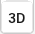 to switch to the 3D view. Then, select the outline to be adjusted and specify information such as the building height.
- Click Next to save the settings.
Drawing Obstacles
There may be obstacles such as windows, skylights, and tree branches that affect PV module installation and PV power generation efficiency on or around a building's roof. You can draw obstacles based on site requirements.
- Drawing rectangular obstacles
  - Click , choose Rectangle, and then click and hold the left mouse button to draw a rectangle in the actual position of the obstacle.
  - Click to switch to the 3D view. Select the obstacles to be adjusted and specify information, such as the obstacle height.
  - After the drawing is complete, click Next to save the settings.
- Drawing polygonal obstacles
  - Click , select Polygon, click the vertices of a polygon obstacle in sequence to draw the outline. Double-click the last vertex to complete the drawing.
  - Click to switch to the 3D view. Select the obstacles to be adjusted and specify information, such as the obstacle height.
  - After the drawing is complete, click Next to save the settings.
- Drawing trees
  - Click , choose Pyramidal or Round, and then click and hold the left mouse button to draw a tree and adjust the tree dimensions.
  - Optional: Click and hold a tree to adjust its position.
  - Click to switch to the 3D view. Click a tree to display the top of the tree. Drag the top of the tree to adjust the height.
  - After the drawing is complete, click Next to save the settings.
You can manually adjust the dimensions of obstacles and trees in the Settings area.
Drawing Carports
The system allows users to draw carports for scenarios where PV modules are placed on carports. You can draw carports and adjust their length and width in both 2D and 3D views, and adjust the height in the 3D view.
- Click and select the desired carport type.
- Click and hold the left mouse button to draw a carport in the target area and release the button when the carport dimensions meet your requirements.
Select the carport, then drag the edges to adjust the dimensions, or manually enter them in the Settings area.
Auto Identification
The system can automatically identify the outlines of the roof, ridge lines, and obstacles. This function is supported only in certain European countries. The actual software UI may vary.
Select a scope as small and precise as possible and ensure that all target buildings are included.
- Automatically identifying a building
Click and then click and hold the left mouse button to select a target building. Then, the roof outline, ridge lines, and obstacles on the roof within the selected range will be automatically identified based on the selected range.
- Automatically identifying a roof outline
Click and then click and hold the left mouse button to select a target building. Then, the roof outline will be automatically identified based on the selected range.
- Automatically identifying a ridge line
Click and double-click the roof where you want to draw an obstacle. Then, the system automatically draws an obstacle.
- Automatically identifying an obstacle
Click and double-click the roof where you want to draw an obstacle. Then, the system automatically draws an obstacle.
Drawing Ridges
After drawing the top view of a building, you can quickly draw the ridges.
- Click and choose Identify Ridge Line. Double-click the roof you want to draw ridges on, and the system automatically places them. Adjust the ridges as required.
- Click to switch to the 3D view. Select a ridge and set the ridge height.
- After the drawing is complete, click Next to save the settings.
Calibrating Dimensions
This function can be used to calibrate building outline dimensions.
- Click , choose Calibrate, and double-click the line to be calibrated in the building outline.
- Enter the calibrated dimensions in the data bars and press Enter.
- After the calibration is complete, click Next to save the settings.
Replacing Images
If there is a clearer rooftop photo, for example, a photo taken by drones, you can use the Replace Image function to replace the photo for 3D modeling design.
- Click and choose Image.
- Click Replace Image on the right of the page.
- Browse to the target folder and select the target image.
- Adjust the replacement range in the Available and Uploaded image boxes, and click OK.
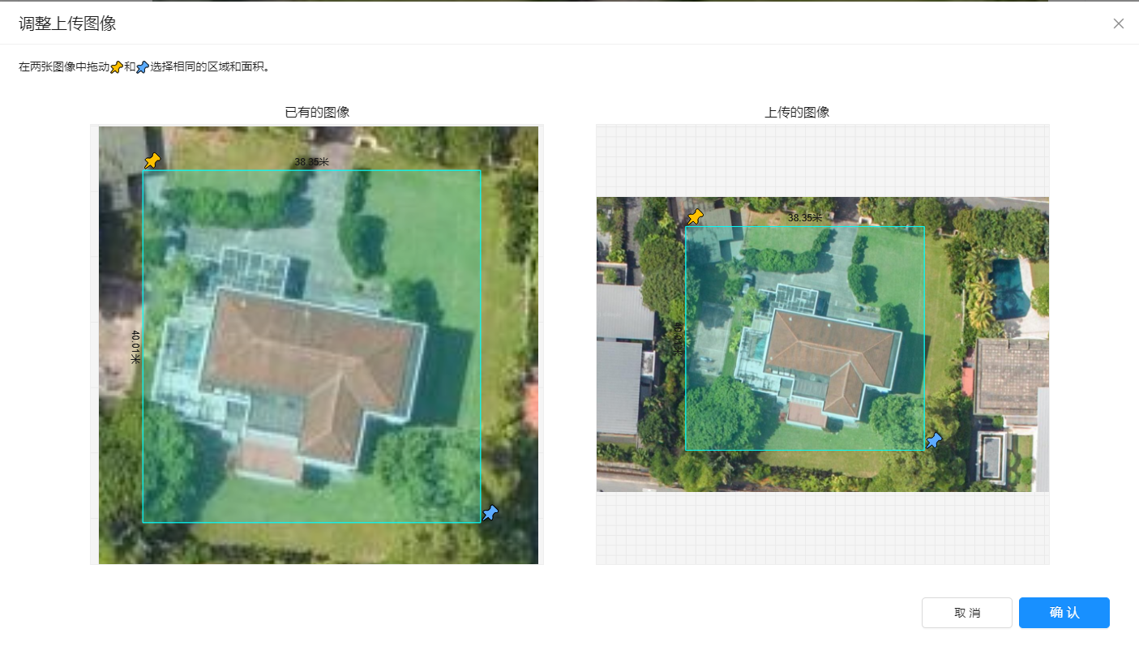
- Adjust the scaling factor, rotation degree, and transparency as required.
- Click Save.
Shortcut Key Operations
Operation | Shortcut Key
Copying a target | Press Ctrl + C (uppercase or lowercase).
Undoing an operation | Press Ctrl + Z (uppercase or lowercase).
Selecting multiple targets | Hold down Ctrl and select the targets.
Moving a single target | Move the target in a drag-and-drop mode.
Moving multiple targets | Hold down Ctrl and select the targets. Then, move the selected targets in a drag-and-drop mode.
Deleting a target | Press Delete.
Drawing vertical or parallel lines | Hold down Shift and draw lines.
Stopping drawing lines | Press Esc.

Importing the Model
If you have a building model in OBJ format, click to upload the building model and draw a rooftop and obstacles on the building model.
Basic Operations
Moving a model: Select a model and hold down the square to move the model.
Rotating a model: Select a model and hold down the arc to rotate the model.
Zooming in or out a model: Select a model and drag the arrow of the model to zoom it in or out.
Editing parameters: Select a model and edit the building name and azimuth on the Settings panel.
Exiting the Model page: Select a model and press Delete. The model is deleted and you exit the Model page.
Rooftop
You can draw a rooftop on the model as required to facilitate the arrangement of PV modules and electrical design in the rooftop area.
- Drawing a rooftop
  - Draw a rooftop: Click . Then in the rooftop area of the building model, click the left mouse button to determine the first vertex for the rooftop of the building model. Move the cursor and click other vertices along the rooftop outline in sequence to draw a rooftop.
  - Exit drawing: Double-click the left mouse button or click the first vertex.
- Editing a rooftop
- Edit a vertex: In the drawing area, click a vertex of the rooftop and edit its position by clicking the arrow of the vertex. You can also edit it in the Settings panel.
- Edit a line: In the drawing area, click a line of the rooftop and edit its position by dragging the line. You can also edit it in the Settings panel.
- Edit a plane: In the drawing area, double-click a vertex or line of the rooftop plane and select the arrow of the rooftop plane to edit its position. You can also edit it in the Settings panel.
- Delete a rooftop: Double-click a vertex or line of the rooftop and click or press Delete.
Obstacle
- Drawing an obstacle
  - Draw an obstacle: Click in the rooftop area. Click the left mouse button to determine the first vertex for the obstacle. Move the cursor and click other vertices along the obstacle outline in sequence to draw an obstacle.
  - Exit drawing: Double-click the left mouse button or click the first vertex.
- Edit an obstacle: In the drawing area, click a vertex of the obstacle and edit the shape and size of the obstacle by dragging the vertex.
Obstacles must be drawn in the rooftop area.
Carport
The system allows users to draw carports for scenarios where PV modules are placed on carports.
- Click and select the desired carport type.
- Click the desire position to place the carport.
- (Optional) In the Settings panel, adjust Length and Width of the carport.
Ruler
- Drawing a ruler
  - Draw a ruler: Click on the toolbar. In the drawing area, click any point to generate a ruler as required.
  - Exit drawing: Double-click the left mouse button or press Esc.
- Edit a ruler: Modify the ruler size by modifying the ruler number. The model size is also modified proportionally.
If either end of the ruler is placed on the ground, the ruler size cannot be modified.

PV Module Layout
After building 3D modeling is complete, you can arrange PV modules on the rooftop as required and specify the PV module model and direction. The system supports automatic and manual layout of PV modules. If you encounter any difficulties during the operation, click User Guide in the lower left corner to view the solution.
User interfaces displayed in this section are for reference only. The actual user interfaces may vary by software versions.
Automatically Arranging PV Modules
- Select the area where PV modules are to be arranged, and select the PV module manufacturer, model, and color on the right.
- Click to add a customized PV module model.
- Click Frequently Used PV Module to set the frequently used PV module models. For details, see 6.2 Setting Frequently Used PV Modules.
- Click Auto and then the system automatically arranges PV modules.
- Click the PV module area, and set the area name, support type, direction, azimuth, tilt angle, and other information of PV modules.
- O&M Channel: If you select this option, you can add row and column spacing in an array for maintenance access. By default, five rows and five columns of O&M channels are available. You can change the number as required.
- Click  in the lower left corner to generate a radiation analysis chart.
- Optional: To delete a PV module, select it and press Delete.
- Click Next to save the current scheme.
Manually Arranging PV Modules
- Select the area where PV modules are to be arranged, and select the PV module manufacturer, model, and color on the right.
- Click to add a customized PV module model.
- Click Frequently Used PV Module to set the frequently used PV module models. For details, see 6.2 Setting Frequently Used PV Modules.
- Click Manual and draw the area where PV modules are to be arranged on the rooftop. The system automatically arranges PV modules in the selected area.
- Click the PV module area, and set the area name, support type, direction, azimuth, tilt angle, and other information of PV modules.
- O&M Channel: If you select this option, you can add row and column spacing in an array for maintenance access. By default, five rows and five columns of O&M channels are available. You can change the number as required.
- Click in the lower left corner to generate a radiation analysis chart.
- Click Next to save the current scheme.
Laying out PV Modules in a Vacant Space
PV modules can be arranged in a vacant space.
- Click and choose Create Vacant Space.
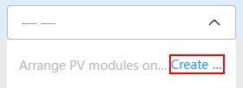
- Click any position on the edge of the space where the PV module is arranged to draw the first outline vertex. Move the pointer to generate a blue path line. Then, click the mouse along the edge of the space to draw the outline path.
- Click the drawn area and select the PV module manufacturer, model, and color on the right.
- Arrange the PV modules in the vacant space automatically or manually.
Shortcut Key Operations
- Click to rotate a PV module.
- Hold down the left mouse button to rotate the view.
- Hold down the right mouse button to drag the view.
- Click a PV module to select it.
- Hold down Ctrl and click PV modules to select them.
- After clicking PV modules, press Ctrl and A to select all PV modules.
- Click a PV module, hold down Shift, and click other PV modules to select them.
- Select a PV module by cursor and move the PV module inside or outside the building.
- Select a PV module and press Delete to delete the PV module.
- Select a PV module and click in the upper left corner or press Ctrl+C to copy the PV module.

Electrical Design
After PV modules are arranged, the system automatically generates inverters, optimizers, and corresponding connections based on the number of PV modules and the target capacity ratio to quickly complete electrical design. If you encounter any difficulties during the operation, click User Guide in the lower left corner to view the solution.
In Europe, a maximum of three inverters can be connected.
Automatic Design
- Determine whether to configure optimizers, ESSs, communications devices, and meters based on site requirements.
- You can set Target Capacity Ratio and decide whether to enable Three-Phase Imbalanced Output as required.
- Click Auto. The system automatically adds inverters, optimizers, and ESSs, and connects cables based on the positions and quantity of PV modules.
- The system automatically recommends communication devices and meters. You can also modify them based on the site requirements.
- Click Next to save the current scheme.
Manual Design
- Determine whether to configure optimizers, ESSs, communications devices, and meters based on site requirements.
- You can set Target Capacity Ratio and decide whether to enable Three-Phase Imbalanced Output as required.
- Click Manual. Then, the system automatically adds inverters, optimizers, and ESSs based on the quantity of PV modules. If the actual requirements are not met, you can click Add Device to add groups of devices.
- Click OK. Then, the system automatically adds inverters, optimizers, and ESSs, and connects cables based on the positions and quantity of PV modules.
- The system automatically recommends communication devices and meters. You can also modify them based on the site requirements.
- Click Next to save the current scheme.
- If you need to configure the ESS, set loads first.
- You can enable Three-Phase Imbalanced Output only when you select a three-phase grid in Grid Parameters on the Basic Info page.
- If Three-Phase Imbalanced Output is selected, only inverters that support the function can be selected.
- You can set Total ESS Capacity and select Support Power Backup only after the ESS is selected.
- For details about the device networking, see 8.1 Residential Solution Overview.
Other Operations
- Click on the right of PV Module Connection Status to perform the connection again.
- Click on the right of PV Module Connection Status to clear the current connection.
- To delete an unconnected PV module, click on the right of PV Module Connection Status and select Delete Unconnected PV Module.
- Click to filter for the buildings or regions connected to PV strings.
- Click on the right of a device to delete its cable connections.
- Click to modify the device model.
- Click next to the MPPT to disconnect a string from the current inverter. The disconnected string is displayed in red.
- Click to view related technical parameters or alarm handling suggestions.
- Click to view the distribution of all inverters.

Economic Analysis
After the design of inverters and PV modules is determined, you can perform economic analysis on the PV system by specifying parameters such as Cost Settings and Government Subsidy.
User interfaces displayed in this section are for reference only. The actual user interfaces may vary by software versions.
Cost Settings
- Click Set to set the discount rate and national tax rate as required.
- In Initial Installation Cost, select Initial Installation Cost Type and enter the price as required.
- If Initial Installation Cost Type is set to Total Device Cost, to set the unit price of each device, click 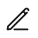 in the Operation column in Devices.
- Total Initial Installation Cost displays the sum of the purchase fees of all devices in the first year.
- Enter the O&M cost in O&M Cost as required.
Total O&M Cost displays the sum of the O&M costs of PV devices and ESS devices each year.
- In the Devices list, confirm the devices and click . In the dialog box that is displayed, enter the description and click OK.
If other devices or auxiliary materials need to be added, click Add Device. In the dialog box that is displayed, enter basic information as prompted and click OK.
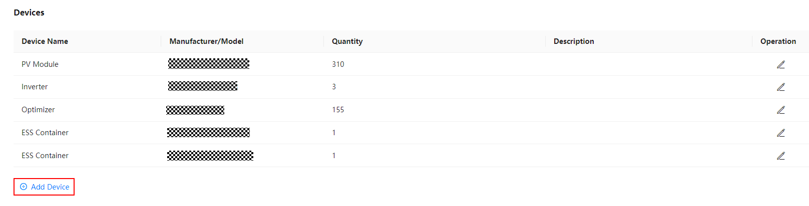
Government Subsidy Settings
If local government subsidies are available, set government subsidies for better economic analysis.
- Click Add Government Subsidy.
- Select a subsidy type and set the subsidy amount and other parameters as required.
- Click Next to generate a report.

Generating a Report
After a report is generated, the system provides information such as energy yield and revenue based on the design scheme. You can customize report contents or export the report.
User interfaces displayed in this section are for reference only. The actual user interfaces may vary by software versions.
Report Details
The report contains multiple parts, such as Basic Info, Project Overview, Electricity Bills Analysis, and Economic Benefits. Click Custom and select the parts to be displayed in the report. For details about the parameters in the report, see 8.2 Report Parameters.
Basic Info: displays the project name and address in the design scheme.
Project Overview: displays the 3D effect, system capacity, and device list in the design scheme.
Click Edit in the lower right corner of the view to zoom in, zoom out, and return to the center position.
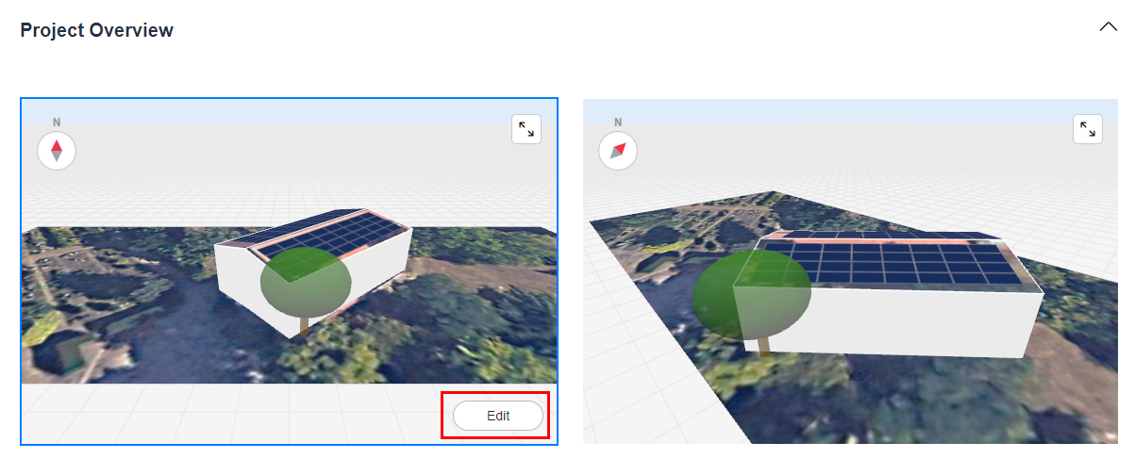
Optimizer Revenue: displays the increased energy yield with optimizers, active safety function, and module-level monitoring function when optimizers are deployed in the PV system.
- The More Roof Directions Supported parameter is displayed only when the number of roof orientations is greater than the total number of selected MPPTs.
- Click Edit in the lower right corner of the view to zoom in, zoom out, and return to the center position.
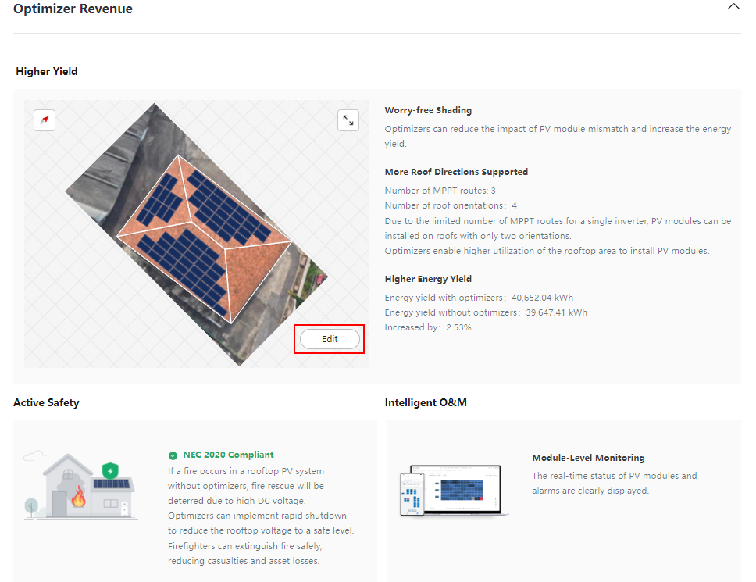
Electricity Bills Analysis: displays the electricity bills comparison before and after PV or PV+ESS installation.
Economic Benefits: displays the expected economic benefits and investment return of the design scheme in the future.
Energy Management: displays the detailed energy distribution in the scheme. When optimizers are deployed in the PV system, the energy yield increase with optimizers, and comparison between scenarios with and without optimizers will also be displayed.
Power Curve: displays the comparison of the grid power before and after PV+ESS or PV installation in each month of a year.
PV Module Layout: displays the PV module layout effect diagram and PV module array list.
Click Edit in the lower right corner of the view to zoom in, zoom out, and return to the center position.
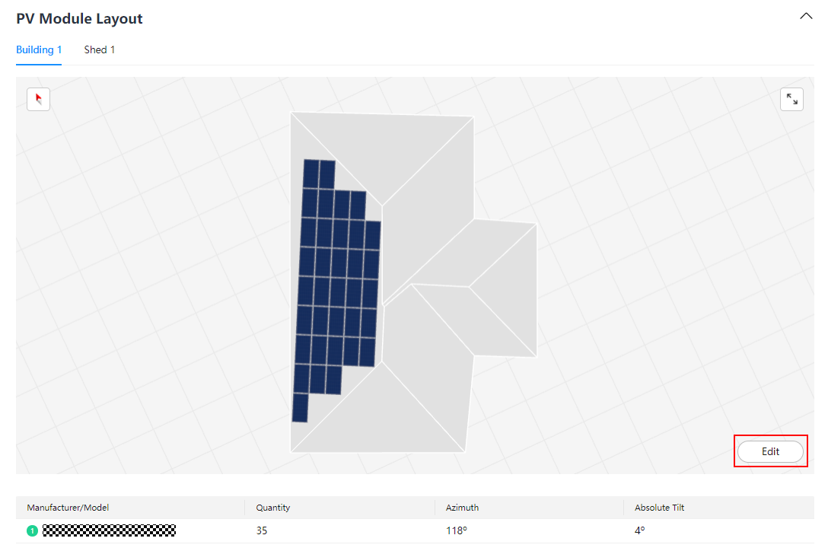
Electrical Connection: displays detailed electrical connections of inverters, MPPT circuits, and PV strings.
System Loss Diagram: displays the loss caused by various factors, such as shading, incidence angle, and optimizer efficiency. The loss diagram intuitively presents each loss phase of the PV system. This helps evaluate the overall efficiency of the system and determine the performance bottleneck, providing input for subsequent optimization. For the loss details, see the actual user interfaces.
First-Year Environmental Benefits: displays the statistics of the scheme's contributions to energy saving and emission reduction.
Simulation Parameters: is used to calculate the simulated energy yield.
If the values of economic parameters such as the payback period are 0 in the report, you are advised to check whether the PV+ESS system price and O&M cost are properly set based on the actual situation.
Advanced Settings
If the value of PV Yield in the Monthly Energy Consumption in the First Year chart in the Energy Management section of the report differs significantly from the actual PV yield, you can set the energy yield coefficient to adjust the value of Theoretical Monthly Energy Yield in First Year to narrow the gap. The procedure is as follows:
- On the report page, click Advanced Settings and enter Energy Yield Coefficient.
- Click OK to save the settings.
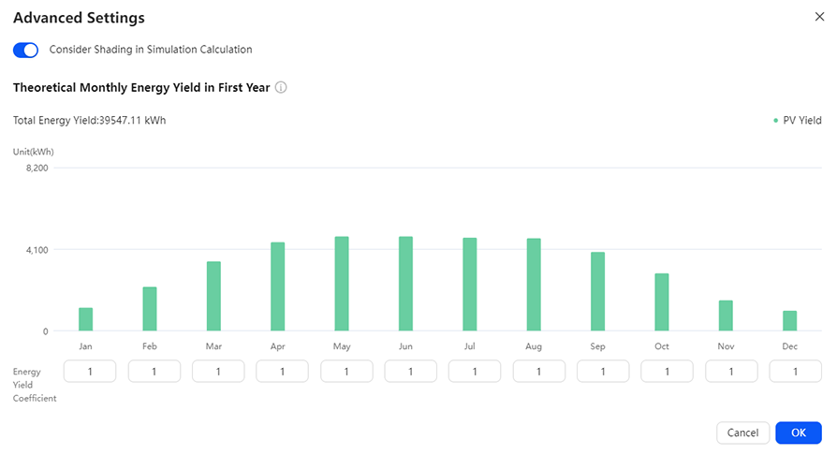
- If the DC power of PV modules in a project does not exceed 10 MW, set Consider Shading in Simulation Calculation.
- PV Yield in the Monthly Energy Consumption in the First Year chart: energy yield of the PV system in each month of the first year with losses deducted
- Theoretical Monthly Energy Yield in First Year: theoretical energy yield of the PV system in each month of the first year without losses deducted
- Energy Yield Coefficient: monthly energy yield coefficient, which is used to adjust the theoretical monthly energy yield in the first year
Exporting a Report
On the Report page, click Export Report.
Sharing a Report
On the Report page, click Share Report. In the Share Report dialog box, copy the static report link and share the generated report.
By default, the report sharing link is open and valid for six months. To set the sharing link, perform the following operations:
- In the Share Report dialog box, click Set Permissions.
- Set the validity period of the sharing link and whether to allow sharing. When Share is disabled, the static report content cannot be viewed.
Exporting Electrical Design
On the Report page, click Export Electrical Design to export the electrical design diagram in PDF or DXF format.

Quick Design
After logging in to the system, click Quick Design in the Residential scenario, and then design the project and fill in the project information as prompted. Then, the project is created and a report is generated.
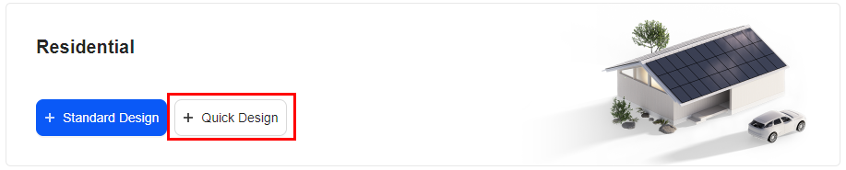
The process of creating a quick design project and generating a report is as follows:

Entering Basic Information
The basic information includes the PV plant location, weather station, and grid parameters.
- Enter the project name, select the PV plant location, weather station, annual power consumption, and power grid parameters based on the site requirements.
- The default value of Annual Energy Consumption is 0. You can configure ESSs in plant design only after this value is reset.
- Grid Parameters can be edited only after the address is entered. The default value is the first value in the drop-down list box. You can select the value based on the site requirements.
- Feed-in is selected by default. If you do not select this parameter, you cannot configure Feed-in Power Upper Limit.
- If there is no feed-in power upper limit, you do not need to configure Feed-in Power Upper Limit.
- If no weather stations provided by the system meet the requirements, click to upload the meteorological data. For details about the upload requirements, see 7.4 How Do I Import Meteorological Data?
- Click Next to save the settings.

Plant Design
After the basic information about the plant is entered, the system automatically configures the inverter list based on the number of PV modules and the target capacity ratio to quickly complete the plant design.
User interfaces displayed in this section are for reference only. The actual user interfaces may vary by software versions.
- Set PV module information, such as the manufacturer and model.
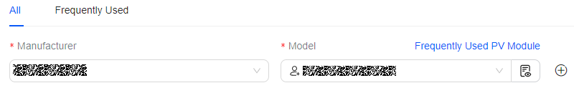
- Click to add a customized PV module model.
- Click Frequently Used PV Module to set the frequently used PV module models. For details, see 6.2 Setting Frequently Used PV Modules.
- Set the PV array name and quantity of PV modules.
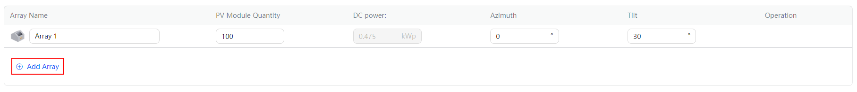
- When you enter the Plant Design page for the first time, only one PV array is displayed by default. You can add, edit, and delete PV arrays in the PV array list. A maximum of five PV arrays can be configured.
- The default value of PV Module Quantity is 100. Enter an integer from 2 to 100000.
- Determine whether to configure optimizers, ESSs, communications devices, and meters based on site requirements.
- Set Target Capacity Ratio and decide whether to enable Three-Phase Imbalanced Output as required.
- If you need to configure the ESS, set loads first.
- You can enable Three-Phase Imbalanced Output only when Grid Parameters is set to a three-phase grid on the Basic Info page.
- If Three-Phase Imbalanced Output is selected, only inverters that support the function can be selected.
- You can set Total ESS Capacity and select Support Power Backup only after the ESS is selected.
- For details about the device networking, see 8.1 Residential Solution Overview.
- Click Auto. The system automatically configures devices.
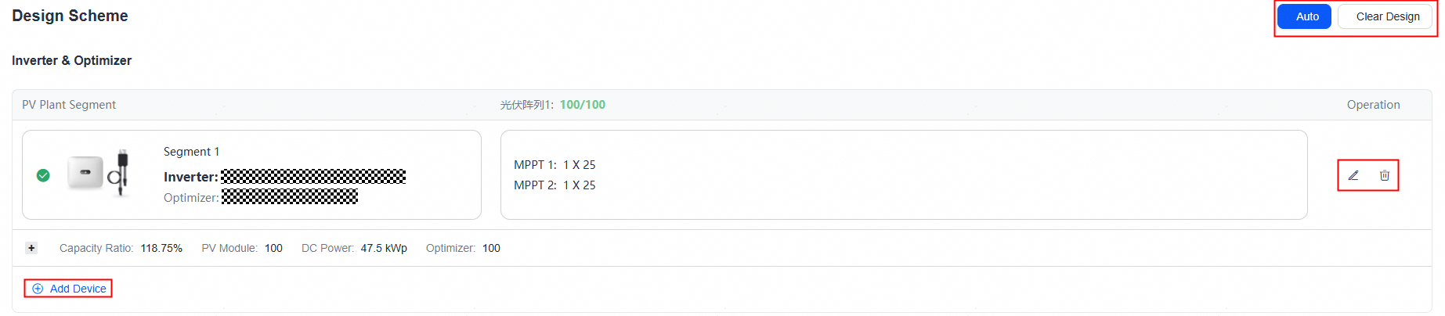
- To clear the existing inverter list, click Clear Design.
- You can modify and delete segments generated by auto design.
- If the existing segments do not meet the actual requirements, click Add Device to add a segment.
- In Europe, a maximum of three inverters can be connected.
- The system automatically recommends communications devices and meters. You can also modify them based on the site requirements.
- Click Next to save the current scheme.

Generating a Report
User interfaces displayed in this section are for reference only. The actual user interfaces may vary by software versions.
Report Details
A report contains multiple parts, such as Basic Info and Project Overview. For details about the parameters in the report, see 8.2 Report Parameters.
Basic Info: displays the project name and address in the design scheme.
Project Overview: displays the system capacity and device list in the design scheme.
Energy Management: displays the detailed energy distribution in the scheme.
Power Curve: displays the comparison of the grid power before and after PV+ESS or PV installation in each month of a year.
Module Layout: displays the manufacturer, model, and number of PV modules in the array.
Electrical Connection: displays detailed electrical connections and relationships between devices (such as the inverter and PV string) in the scheme.
System Loss Diagram: displays the loss caused by various factors, such as shading, incidence angle, and optimizer efficiency. The loss diagram intuitively presents each loss phase of the PV system. This helps evaluate the overall efficiency of the system and determine the performance bottleneck, providing input for subsequent optimization. For the loss details, see the actual user interfaces.
First-Year Environmental Benefits: displays the statistics of the scheme's contributions to energy saving and emission reduction.
Simulation Parameters: is used to calculate the simulated energy yield.
Advanced Settings
If the value of PV Yield in the Monthly Energy Consumption in the First Year chart in the Energy Management section of the report differs significantly from the actual PV yield, you can set the energy yield coefficient to adjust the value of Theoretical Monthly Energy Yield in First Year to narrow the gap. The procedure is as follows:
- On the report page, click Advanced Settings and enter Energy Yield Coefficient.
- Click OK to save the settings.
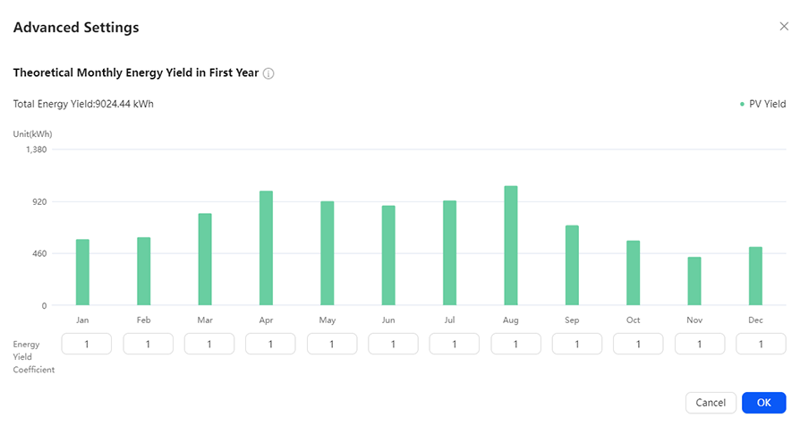
- PV Yield in the Monthly Energy Consumption in the First Year chart: energy yield of the PV system in each month of the first year with losses deducted.
- Theoretical Monthly Energy Yield in First Year: theoretical energy yield of the PV system in each month of the first year without losses deducted.
- Energy Yield Coefficient: monthly energy yield coefficient, which is used to adjust the theoretical monthly energy yield in the first year.
Exporting a Report
On the Report page, click Export Report.
Sharing a Report
On the Report page, click Share Report. In the Share Report dialog box, copy the static report link and share the generated report.
By default, the report sharing link is open and valid for six months. To set the sharing link, perform the following operations:
- In the Share Report dialog box, click Set Permissions.
- Set the validity period of the sharing link and whether to allow sharing. When Share is disabled, the static report content cannot be viewed.

Commercial and Industrial Project

Standard Design
After logging in to the system, click Standard Design in the C&I scenario, and then design the project and fill in the project information as prompted. Then, the project is created and a report is generated.
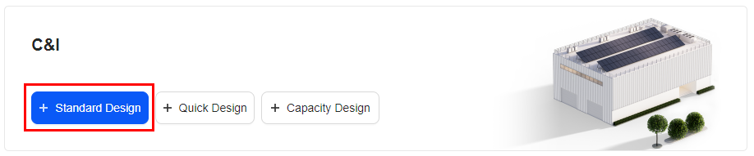
The process of creating a standard design project and generating a report is as follows.

Entering Basic Information
The basic information includes the PV plant location, weather station, and grid parameters.
- Enter the project name, and set basic information such as the location of the PV plant, weather station, and power grid parameters based on the site requirements.
If no weather stations provided by the system meet the requirements, click to upload the meteorological data. For details about the upload requirements, see 7.4 How Do I Import Meteorological Data?
- Frame the location where the PV plant is to be installed.
- Method 1: Hold down on the map, move the cursor to the location where the PV plant is to be installed, and adjust the frame size to ensure that the location is completely framed.
- Method 2: Hold down any place on the map, move the cursor to the location where the PV plant is to be installed, and adjust the frame size to ensure that the location is completely framed.
- Click Next to save the settings.

Electricity Price & Consumption Settings
After the electricity price and energy consumption load are set, the system calculates the revenue and self-consumption of a PV plant system based on the energy consumption.
Electricity Price Settings
To configure ESSs and ensure the accuracy of benefit calculation, set the effective electricity price and related parameters in Electricity Price Settings as required.
- Click Set and select a currency unit as required.
- Set Feed-in Tariff.
- Set Purchase Price.
- Select User-Defined Input in Type.
    - Set Volumetric Charge Type and the electricity price as required.
            - If you want to set a time-of-use electricity price, set Volumetric Charge Type to Time-of-Use. For details, see 7.1 How Do I Set the Time-of-Use Electricity Prices?
    - Set the demand charge rate as required.
    - If you set the demand charge rate to By Actual Demand, you need to set parameters such as Maximum Demand Mode and Monthly Demand Charge.
    - If you set the demand charge rate to Transformer Capacity, you need to set parameters such as Transformer Capacity and Price.
Parameter | Description
Maximum Demand Mode | Set the settlement period of the maximum demand charge. The statistics can be collected by year, month, or time period.
Monthly Demand Charge | The basic demand charges are calculated based on the maximum demand statistical period and are converted into monthly electricity bills.
Volumetric Charge Type | The volumetric charge type can be set to Fixed or Time-of-Use.

- Select Template Input in Type.
    - Click Select Template.
    - Select the required template and click OK.
- If a price template has been configured in the Management System, the Template Input option is provided for the electricity purchase price type. You can select the option as required.
- If the price template does not meet the requirements, you can configure a template in the Management System.
- Set Type to Data Import.
    - Click Download Template, enter the load data in the template as required, and save the template.
    - Click Add File, and select and upload the saved template.
- Select the electricity price growth rate and set related parameters based on site requirements.
Consumption Settings
- Creating an energy consumption model through model generation
  - Set Type to Generate Model.
  - Set Annual Energy Consumption and Monthly Energy Consumption as required.
  - Set Workday Model and Weekend Model as required. The system displays the daily load curve based on Workday Model and Weekend Model.
  - Optional: If the preconfigured models do not meet your requirements, set Workday Model or Weekend Model to Custom and click to edit the model.
  - Select a type of consumption growth rate and set related parameters based on site requirements.
- Creating an energy consumption model by importing data
  - Set Type to Data Import.
  - Click Download Template, enter the load data in the template as required, and save the template. For details, see 7.2 How Do I Generate an Energy Consumption Model by Importing Data?
  - Click Add File, and select and upload the saved template.
  - Select a type of consumption growth rate and set related parameters based on site requirements.
- If no load is connected, set Annual Energy Consumption to 0.
- If you need to configure ESSs, set valid electricity prices and loads first.

Performing 3D Modeling
After you specify the location, the system automatically generates a rectangle area. In this area, you can draw buildings or import building models to draw rooftops to facilitate PV module arrangement and electrical design. If you encounter any difficulties during the operation, click User Guide in the lower left corner to view the solutions.
User interfaces displayed in this section are for reference only. The actual user interfaces may vary by software versions.

Drawing the 3D Model
Drawing Buildings
The system provides both 2D and 3D views. The 2D view displays the map in a top view and is used to draw the roof outline and obstacles. The 3D view is used to edit information, such as a building's height.
- By default, the map is displayed in a top view. Click a map area, click , and draw the roof outline based on site requirements. All points form a closed geometric image. Alternatively, you can quickly draw the ridge based on the ridge type (for details, see Drawing Ridges).
If there are obstacles such as windows, skylights, and tree branches that affect PV module installation and PV power generation efficiency on or around the roof, draw the obstacles based on site requirements. For details, see Drawing Obstacles.
- Click to switch to the 3D view. Then, select the outline to be adjusted and specify information such as the building height.
- Click Next to save the settings.
Drawing Obstacles
There may be obstacles such as windows, skylights, and tree branches that affect PV module installation and PV power generation efficiency on or around a building's roof. You can draw obstacles based on site requirements.
- Drawing rectangular obstacles
  - Click , choose Rectangle, and then click and hold the left mouse button to draw a rectangle in the actual position of the obstacle.
  - Click to switch to the 3D view. Select the obstacles to be adjusted and specify information, such as the obstacle height.
  - After the drawing is complete, click Next to save the settings.
- Drawing polygonal obstacles
  - Click , select Polygon, click the vertices of a polygon obstacle in sequence to draw the outline. Double-click the last vertex to complete the drawing.
  - Click to switch to the 3D view. Select the obstacles to be adjusted and specify information, such as the obstacle height.
  - After the drawing is complete, click Next to save the settings.
- Drawing trees
  - Click , choose Pyramidal or Round, and then click and hold the left mouse button to draw a tree and adjust the tree dimensions.
  - Optional: Click and hold a tree to adjust its position.
  - Click to switch to the 3D view. Click a tree to display the top of the tree. Drag the top of the tree to adjust the height.
  - After the drawing is complete, click Next to save the settings.
You can manually adjust the dimensions of obstacles and trees in the Settings area.
Drawing Carports
The system allows users to draw carports for scenarios where PV modules are placed on carports. You can draw carports and adjust their length and width in both 2D and 3D views, and adjust the height in the 3D view.
- Click and select the desired carport type.
- Click and hold the left mouse button to draw a carport in the target area and release the button when the carport dimensions meet your requirements.
Select the carport, then drag the edges to adjust the dimensions, or manually enter them in the Settings area.
Auto Identification
The system can automatically identify the outlines of the roof, ridge lines, and obstacles. This function is supported only in certain European countries. The actual software UI may vary.
Select a scope as small and precise as possible and ensure that all target buildings are included.
- Automatically identifying a building
Click and then click and hold the left mouse button to select a target building. Then, the roof outline, ridge lines, and obstacles on the roof within the selected range will be automatically identified based on the selected range.
- Automatically identifying a roof outline
Click and then click and hold the left mouse button to select a target building. Then, the roof outline will be automatically identified based on the selected range.
- Automatically identifying a ridge line
Click and double-click the roof where you want to draw an obstacle. Then, the system automatically draws an obstacle.
- Automatically identifying an obstacle
Click and double-click the roof where you want to draw an obstacle. Then, the system automatically draws an obstacle.
Drawing Ridges
After drawing the top view of a building, you can quickly draw the ridges.
- Click and choose Identify Ridge Line. Double-click the roof you want to draw ridges on, and the system automatically places them. Adjust the ridges as required.
- Click to switch to the 3D view. Select a ridge and set the ridge height.
- After the drawing is complete, click Next to save the settings.
Calibrating Dimensions
This function can be used to calibrate building outline dimensions.
- Click , choose Calibrate, and double-click the line to be calibrated in the building outline.
- Enter the calibrated dimensions in the data bars and press Enter.
- After the calibration is complete, click Next to save the settings.
Replacing Images
If there is a clearer rooftop photo, for example, a photo taken by drones, you can use the Replace Image function to replace the photo for 3D modeling design.
- Click and choose Image.
- Click Replace Image on the right of the page.
- Browse to the target folder and select the target image.
- Adjust the replacement range in the Available and Uploaded image boxes, and click OK.
- Adjust the scaling factor, rotation degree, and transparency as required.
- Click Save.
Shortcut Key Operations
Operation | Shortcut Key
Copying a target | Press Ctrl + C (uppercase or lowercase).
Undoing an operation | Press Ctrl + Z (uppercase or lowercase).
Selecting multiple targets | Hold down Ctrl and select the targets.
Moving a single target | Move the target in a drag-and-drop mode.
Moving multiple targets | Hold down Ctrl and select the targets. Then, move the selected targets in a drag-and-drop mode.
Deleting a target | Press Delete.
Drawing vertical or parallel lines | Hold down Shift and draw lines.
Stopping drawing lines | Press Esc.

Importing the Model
If you have a building model in OBJ format, click to upload the building model and draw a rooftop and obstacles on the building model.
Basic Operations
Moving a model: Select a model and hold down the square to move the model.
Rotating a model: Select a model and hold down the arc to rotate the model.
Zooming in or out a model: Select a model and drag the arrow of the model to zoom it in or out.
Editing parameters: Select a model and edit the building name and azimuth on the Settings panel.
Exiting the Model page: Select a model and press Delete. The model is deleted and you exit the Model page.
Rooftop
You can draw a rooftop on the model as required to facilitate the arrangement of PV modules and electrical design in the rooftop area.
- Drawing a rooftop
  - Draw a rooftop: Click . Then in the rooftop area of the building model, click the left mouse button to determine the first vertex for the rooftop of the building model. Move the cursor and click other vertices along the rooftop outline in sequence to draw a rooftop.
  - Exit drawing: Double-click the left mouse button or click the first vertex.
- Editing a rooftop
- Edit a vertex: In the drawing area, click a vertex of the rooftop and edit its position by clicking the arrow of the vertex. You can also edit it in the Settings panel.
- Edit a line: In the drawing area, click a line of the rooftop and edit its position by dragging the line. You can also edit it in the Settings panel.
- Edit a plane: In the drawing area, double-click a vertex or line of the rooftop plane and select the arrow of the rooftop plane to edit its position. You can also edit it in the Settings panel.
- Delete a rooftop: Double-click a vertex or line of the rooftop and click or press Delete.
Obstacle
- Drawing an obstacle
  - Draw an obstacle: Click in the rooftop area. Click the left mouse button to determine the first vertex for the obstacle. Move the cursor and click other vertices along the obstacle outline in sequence to draw an obstacle.
  - Exit drawing: Double-click the left mouse button or click the first vertex.
- Edit an obstacle: In the drawing area, click a vertex of the obstacle and edit the shape and size of the obstacle by dragging the vertex.
Obstacles must be drawn in the rooftop area.
Carport
The system allows users to draw carports for scenarios where PV modules are placed on carports.
- Click and select the desired carport type.
- Click the desire position to place the carport.
- (Optional) In the Settings panel, adjust Length and Width of the carport.
Ruler
- Drawing a ruler
  - Draw a ruler: Click on the toolbar. In the drawing area, click any point to generate a ruler as required.
  - Exit drawing: Double-click the left mouse button or press Esc.
- Edit a ruler: Modify the ruler size by modifying the ruler number. The model size is also modified proportionally.
If either end of the ruler is placed on the ground, the ruler size cannot be modified.

PV Module Layout
After building 3D modeling is complete, you can arrange PV modules on the rooftop as required and specify the PV module model and direction. The system supports automatic and manual layout of PV modules. If you encounter any difficulties during the operation, click User Guide in the lower left corner to view the solution.
User interfaces displayed in this section are for reference only. The actual user interfaces may vary by software versions.
Automatically Arranging PV Modules
- Select the area where PV modules are to be arranged, and select the PV module manufacturer, model, and color on the right.
- Click to add a customized PV module model.
- Click Frequently Used PV Module to set the frequently used PV module models. For details, see 6.2 Setting Frequently Used PV Modules.
- Click Auto and then the system automatically arranges PV modules. For a large roof, after you click Auto, the system automatically divides it into multiple areas. Each area allows a maximum of 3000 PV modules.
- Click the PV module area, and set the area name, support type, direction, azimuth, tilt angle, and other information of PV modules.
- O&M Channel: If you select this option, you can add row and column spacing in an array for maintenance access. By default, five rows and five columns of O&M channels are available. You can change the number as required.
- Click in the lower left corner to generate a radiation analysis chart. When the DC power of PV modules exceeds 5000 kWp, you need to select buildings before generating the radiation analysis chart. The radiation analysis charts of a maximum of five buildings can be displayed at a time.
- For a project where PV modules have been arranged, if the DC power of PV modules exceeds 5000 kWp, the PV module placeholder diagram is displayed by default on the Module Layout page when you access the project again. If you click this area, the placeholder diagram is switched to the PV module layout. To delete a PV module, select it and press Delete.
              - PV module layout
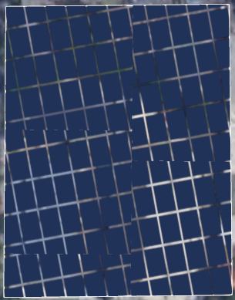

- Click Next to save the current scheme.
Manually Arranging PV Modules
- Select the area where PV modules are to be arranged, and select the PV module manufacturer, model, and color on the right.
- Click to add a customized PV module model.
- Click Frequently Used PV Module to set the frequently used PV module models. For details, see 6.2 Setting Frequently Used PV Modules.
- Click Manual and draw the area where PV modules are to be arranged on the rooftop. The system automatically arranges PV modules in the selected area.
- Click the PV module area, and set the area name, support type, direction, azimuth, tilt angle, and other information of PV modules.
- O&M Channel: If you select this option, you can add row and column spacing in an array for maintenance access. By default, five rows and five columns of O&M channels are available. You can change the number as required.
- Click in the lower left corner to generate a radiation analysis chart. When the DC power of PV modules exceeds 5000 kWp, you need to select buildings before generating the radiation analysis chart. The radiation analysis charts of a maximum of five buildings can be displayed at a time.
- Click Next to save the current scheme.
Laying out PV Modules in a Vacant Space
PV modules can be arranged in a vacant space.
- Click and choose Create Vacant Space.
- Click any position on the edge of the space where the PV module is arranged to draw the first outline vertex. Move the pointer to generate a blue path line. Then, click the mouse along the edge of the space to draw the outline path.
- Click the drawn area and select the PV module manufacturer, model, and color on the right.
- Arrange the PV modules in the vacant space automatically or manually.
Shortcut Key Operations
- Click to rotate a PV module.
- Hold down the left mouse button to rotate the view.
- Hold down the right mouse button to drag the view.
- Click a PV module to select it.
- Hold down Ctrl and click PV modules to select them.
- After clicking PV modules, press Ctrl and A to select all PV modules.
- Click a PV module, hold down Shift, and click other PV modules to select them.
- Select a PV module by cursor and move the PV module inside or outside the building.
- Select a PV module and press Delete to delete the PV module.
- Select a PV module and click in the upper left corner or press Ctrl+C to copy the PV module.

Electrical Design
After PV modules are arranged, the system automatically generates inverters, optimizers, and corresponding connections based on the number of PV modules and the target capacity ratio to quickly complete electrical design. If you encounter any difficulties during the operation, click User Guide in the lower left corner to view the solution.
Automatic Design
- Select devices such as Optimizer, ESS, Communications Device, and Meter as required.
- You can set Target Capacity Ratio as required.
- Click Auto. The system automatically adds devices such as inverters, optimizers, and ESSs, and connects cables based on the positions and quantity of PV modules.
- The system automatically recommends communications devices and meters. You can modify them as required.
- Click Next to save the current scheme.
Manual Design
- Select devices such as Optimizer, ESS, Communications Device, and Meter as required.
- You can set Target Capacity Ratio as required.
- Click Manual. The system automatically adds devices such as inverters and optimizers based on the positions and quantity of PV modules. If the actual requirements are not met, you can click Add Device to add groups of devices.
- Click Confirm. The system automatically connects PV modules, inverters, and optimizers based on the positions and quantity of PV modules.
- If Communications Device and Meter are selected in the Select Device area, the system automatically recommends these devices for you. You can also modify them as required.
- Click Next to save the current scheme.
Other Operations
- Click on the right of PV Module Connection Status to perform the connection again.
- Click on the right of PV Module Connection Status to clear the current connection.
- To delete an unconnected PV module, click on the right of PV Module Connection Status and select Delete Unconnected PV Module.
- Click to filter for the buildings or regions connected to PV strings.
- Click on the right of a device to delete its cable connections.
- Click to modify the device model.
- Click next to the MPPT to disconnect a string from the current inverter. The disconnected string is displayed in red.
- Click to view related technical parameters or alarm handling suggestions.
- Click to view the distribution of all inverters.
- If the DC power of PV modules exceeds 5000 kWp, the electrical design placeholder diagram is displayed by default on the Electrical Design page when you access the project again. If you click this area, the placeholder diagram is switched to the electrical design diagram.
              - Electrical design placeholder diagram
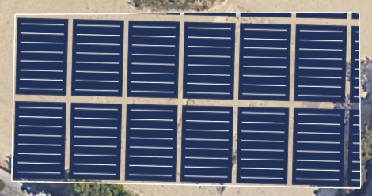

ESS Design
ESS Design is supported only after ESS is selected in the Select Device area on the Electrical Design page.
Auto Design
- Configure ESS Type and PV+ESS Operating Mode as required.
PV+ESS Operating Mode | Description
Maximum Self-Consumption | PV energy is supplied preferentially to loads, and surplus PV energy is used to charge the ESS. If the ESS is fully charged or is being charged at full power, the surplus PV energy is fed to the grid. When PV energy is insufficient or cannot be generated at night, the ESS discharges energy to loads. This improves the self-consumption rate and energy self-sufficiency rate, and reduces electricity costs.
Maximum Self-Consumption+TOU | PV energy is supplied preferentially to loads, and surplus PV energy is used to charge the ESS. The ESS is charged and discharges energy based on the TOU policy. That is, the ESS is charged based on the maximum charge power calculated by the algorithm during the charge period. In the No Charge or Discharge period, the surplus PV energy is used to charge the ESS.
Maximum Self-Consumption+Peak Shaving | PV energy is supplied preferentially to loads, and surplus PV energy is used to charge the ESS. In the ESS charge period, the power obtained from the grid is controlled based on the demand calculated by the algorithm. In the No Charge or Discharge period, the surplus PV energy is used to charge the ESS.
Maximum Self-Consumption+TOU+Peak Shaving | PV energy is supplied preferentially to loads, and surplus PV energy is used to charge the ESS. The ESS is charged and discharges energy based on the TOU policy. That is, in the ESS charge period, the charge power is controlled based on the demand calculated by the algorithm. In the No Charge or Discharge period, if the sum of the power from the grid plus the PV power does not meet the consumption requirements according to the peak shaving rule, the ESS discharges if it has energy so that the grid can obtain power from the ESS.

- Click Auto.
- In the Edit Auto Design Parameter dialog box, set Plan Settings, Cost Settings, O&M Cost, Loan Settings, and Government Subsidy as required.
- Click Auto. The system automatically configures the ESSs.
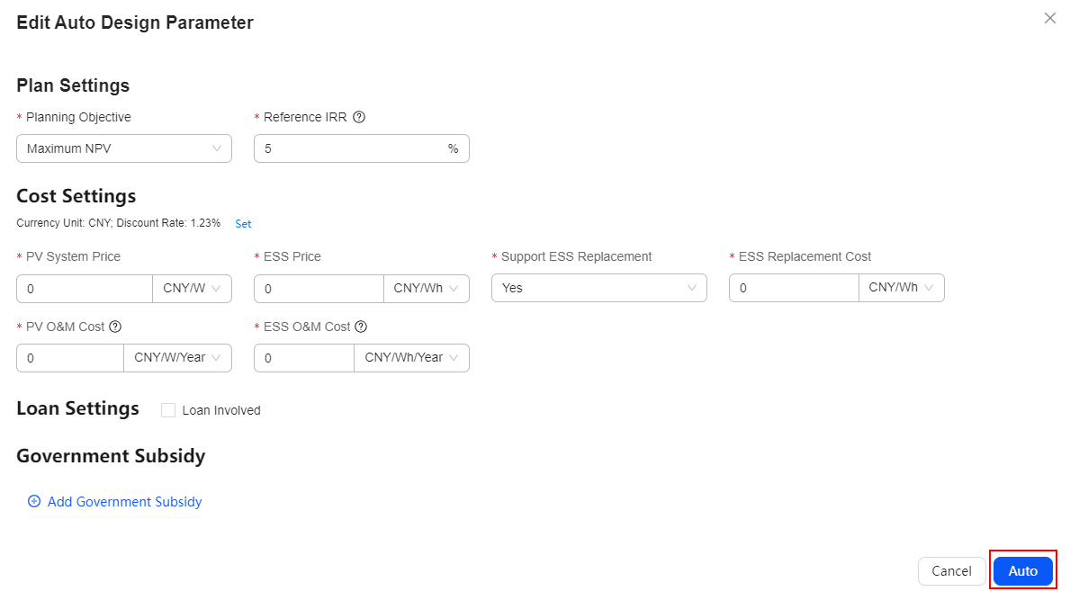
- To clear the existing ESS list, click Clear Design.
- If you want to modify some parameters after the automatic design is complete, click Auto. After the parameters are modified, perform the automatic design.
- Click Next to save the current scheme.
Manual Design
After the ESSs are automatically designed, you can perform manual design if the current design does not meet actual requirements.
- Click Manual Edit.
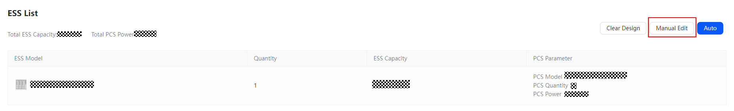
- After you click Manual Edit, the ESS capacity benefit comparison chart becomes invalid.
- After you click Manual Edit, the ESS list retains the auto design result.
- Set parameters based on the actual situation.
- If the existing ESS model does not meet the requirements, click Add Device to add an ESS model.
- A maximum of four ESS models can be added.
- To clear the existing ESS list, click Clear Design.
- Click Next to save the current scheme.

Economic Analysis
After determining the design of inverters, PV modules, and ESSs, you can analyze the PV benefits.
User interfaces displayed in this section are for reference only. The actual user interfaces may vary by software versions.
Cost Settings
- Click Set to set the discount rate as required.
- In the Initial Installation Cost area, select Initial Installation Cost Type and enter the price based on site requirements.
- If Initial Installation Cost Type is set to Total Device Price, to set the unit price of each device, click in the Operation column in Devices.
- Total Initial Installation Cost displays the sum of the purchase fees of all devices in the first year.
- In O&M Cost, enter the O&M cost as required.
Total O&M Cost displays the sum of the O&M costs of PV devices and ESS devices each year.
- In the Devices list, confirm the devices and click . In the dialog box that is displayed, enter the description and click OK.
If other devices or auxiliary materials need to be added, click Add Device. In the dialog box that is displayed, enter basic information as prompted and click OK.
After the ESS is automatically designed, the parameters related to the Cost Settings are consistent with those for the ESS automatic design and cannot be modified. If you want to modify these parameters, you need to perform ESS automatic design again.
Loan Settings
If you have a loan, select Loan Involved and set Loan Ratio, Max Loan Amount, and other parameters.
After the ESS is automatically designed, the parameters related to the Loan Settings are consistent with those for the ESS automatic design and cannot be modified. If you want to modify these parameters, you need to perform ESS automatic design again.
Investment Settings
If you want to share the revenue with investors, select Share Revenue with Investor and set investment parameters.
Government Subsidy Settings
If local government subsidies are available, set government subsidies for better economic analysis.
- Click Add Government Subsidy.
- Select a subsidy type and set the subsidy amount and other parameters as required.
- Click Next to generate a report.
After the ESS is automatically designed, the parameters related to the Government Subsidy are consistent with those for the ESS automatic design and cannot be modified. If you want to modify these parameters, you need to perform ESS automatic design again.

Generating a Report
After a report is generated, the system provides information such as energy yield and revenue based on the design scheme. You can customize report contents or export the report.
User interfaces displayed in this section are for reference only. The actual user interfaces may vary by software versions.
Report Details
The report contains multiple parts, such as Basic Info, Project Overview, Electricity Bills Analysis, and Economic Benefits. Click Custom and select the parts to be displayed in the report. For details about the parameters in the report, see 8.2 Report Parameters.
Basic Info: displays the project name and address in the design scheme.
Project Overview: displays the 3D effect, system capacity, and device list in the design scheme.
Click Edit in the lower right corner of the view to zoom in, zoom out, and return to the center position.
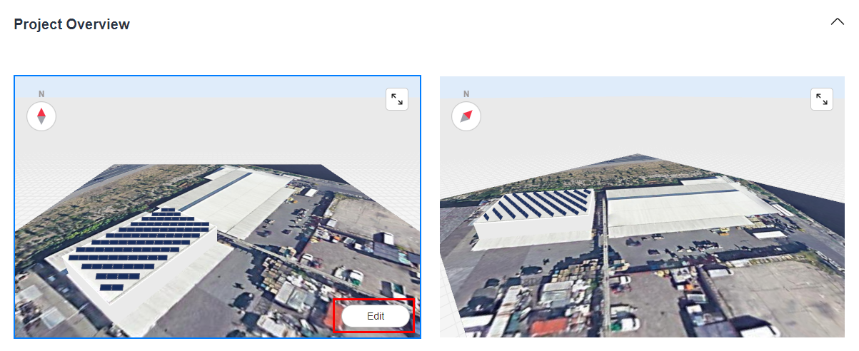
Economic Benefits: displays the expected economic revenue, investment returns, and costs in the design scheme.
Owner's Revenue: displays the accumulated revenue, electricity fee saved, and comparison of different types of electricity purchase fees and accumulated revenue sharing of the owner.
Electricity Bills Analysis: displays the electricity bill comparison and the maximum grid power changes before and after PV or PV+ESS installation.
Energy Management: displays the detailed energy distribution in the scheme.
Networking Diagram: displays the networking diagram of devices.
ESS Configuration Policy: displays the operating mode, charge and discharge configuration policy, round-trip efficiency (RTE), and battery degradation curve of the ESSs.
Power Curve: displays the comparison of the grid power before and after PV+ESS or PV installation in each month of a year, the charge and discharge power in a day, and the electricity price curve.
- You can select a day to view the charge and discharge power curve on that day. The exported report shows the statistics on the day you select.
- When the PV+ESS operating mode is maximum self-consumption, the charge and discharge configuration policies are not displayed in the ESS Configuration Policy area.
Optimizer Revenue: displays the benefits of a PV system when it contains Huawei's optimizers. The benefits include energy yield improvement, active safety, and intelligent O&M.
ESS Benefits: displays the benefits when the ESS type is liquid-cooled ESS. The benefits of Huawei's ESSs include C2C dual-link safety, lower levelized cost of storage (LCOS), and flexible application in all scenarios.
PV Module Layout: displays the PV module layout effect diagram and PV module array list.
Click Edit in the lower right corner of the view to zoom in, zoom out, and return to the center position.
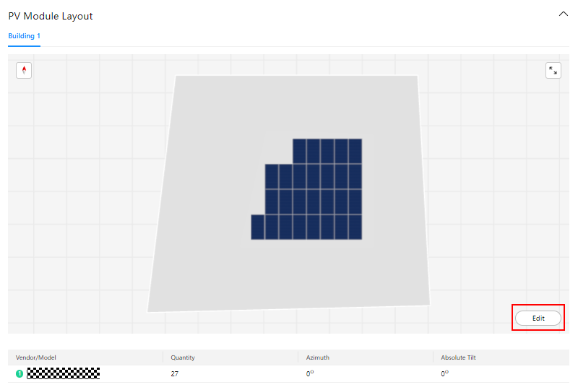
Electrical Connection: displays detailed electrical connections of inverters, MPPT circuits, and PV strings.
System Loss Diagram: displays the loss caused by various factors, such as shading, incidence angle, and optimizer efficiency. The loss diagram intuitively presents each loss phase of the PV system. This helps evaluate the overall efficiency of the system and determine the performance bottleneck, providing input for subsequent optimization. For the loss details, see the actual user interfaces.
First-Year Environmental Benefits: displays the statistics of the scheme's contributions to energy saving and emission reduction.
Simulation Parameters: is used to calculate the simulated energy yield.
If the values of economic parameters such as the payback period are 0 in the report, you are advised to check whether the PV+ESS system price and O&M cost are properly set based on the actual situation.
Advanced Settings
If the value of PV Yield in the Monthly Energy Consumption in the First Year chart in the Energy Management section of the report differs significantly from the actual PV yield, you can set the energy yield coefficient to adjust the value of Theoretical Monthly Energy Yield in First Year to narrow the gap. The procedure is as follows:
- On the report page, click Advanced Settings and enter Energy Yield Coefficient.
- Click OK to save the settings.
- If the DC power of PV modules in a project does not exceed 10 MW, set Consider Shading in Simulation Calculation.
- PV Yield in the Monthly Energy Consumption in the First Year chart: energy yield of the PV system in each month of the first year with losses deducted
- Theoretical Monthly Energy Yield in First Year: theoretical energy yield of the PV system in each month of the first year without losses deducted
- Energy Yield Coefficient: monthly energy yield coefficient, which is used to adjust the theoretical monthly energy yield in the first year
Exporting a Report
On the Report page, click Export Report.
Sharing a Report
On the Report page, click Share Report. In the Share Report dialog box, copy the static report link and share the generated report.
By default, the report sharing link is open and valid for six months. To set the sharing link, perform the following operations:
- In the Share Report dialog box, click Set Permissions.
- Set the validity period of the sharing link and whether to allow sharing. When Share is disabled, the static report content cannot be viewed.
Exporting Electrical Design
On the Report page, click Export Electrical Design to export the electrical design diagram in PDF or DXF format.

Quick Design
After logging in to the system, click Quick Design in the C&I scenario, and then design the project and fill in the project information as prompted. Then, the project is created and a report is generated.
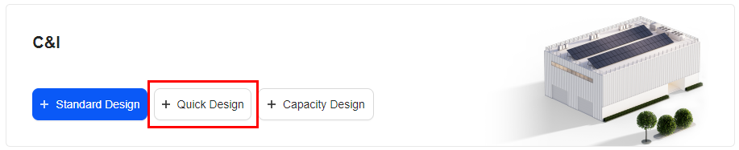
The process of creating a quick design project and generating a report is as follows:

Entering Basic Information
The basic information includes the PV plant location, weather station, and grid parameters.
- Enter the project name, select the PV plant location, weather station, annual power consumption, and power grid parameters based on the site requirements.
- The default value of Annual Energy Consumption is 0. You can configure ESSs in plant design only after this value is reset.
- Grid Parameters can be edited only after the address is entered. The default value is the first value in the drop-down list box. You can select the value based on the site requirements.
- Feed-in is selected by default. If you do not select this parameter, you cannot configure Feed-in Power Upper Limit.
- If there is no feed-in power upper limit, you do not need to configure Feed-in Power Upper Limit.
- If no weather stations provided by the system meet the requirements, click to upload the meteorological data. For details about the upload requirements, see 7.4 How Do I Import Meteorological Data?
- Click Next to save the settings.

Plant Design
After the basic information about the plant is entered, the system automatically configures the inverter list based on the number of PV modules and the target capacity ratio to quickly complete the plant design.
User interfaces displayed in this section are for reference only. The actual user interfaces may vary by software versions.
- Set PV module information, such as the manufacturer and model.
- Click to add a customized PV module model.
- Click Frequently Used PV Module to set the frequently used PV module models. For details, see 6.2 Setting Frequently Used PV Modules.
- Set the PV array name and quantity of PV modules.
- When you enter the Plant Design page for the first time, only one PV array is displayed by default. You can add, edit, and delete PV arrays in the PV array list. A maximum of five PV arrays can be configured.
- The default value of PV Module Quantity is 100. Enter an integer from 2 to 100000.
- Configure parameters of optimizers, communications devices, and meters, and set Target Capacity Ratio as required.
- Click Auto. The system automatically configures devices.
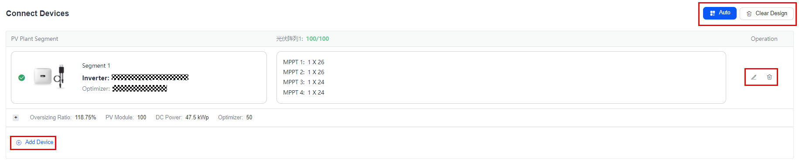
- To clear the existing inverter list, click Clear Design.
- You can modify and delete segments generated by auto design.
- If the existing segments do not meet the actual requirements, click Add Device to add a segment.
- If devices such as Communication Device and Meter are selected, the system recommends the device types for you. You can also modify the device types as required.
- Click Next to save the current scheme.

Generating a Report
User interfaces displayed in this section are for reference only. The actual user interfaces may vary by software versions.
Report Details
A report contains multiple parts, such as Basic Info and Project Overview. For details about the parameters in the report, see 8.2 Report Parameters.
Basic Info: displays the project name and address in the design scheme.
Project Overview: displays the system capacity and device list in the design scheme.
Energy Management: displays the detailed energy distribution in the scheme.
Networking Diagram: displays the networking diagram of devices.
Power Curve: displays the comparison of purchased power before and after PV installation in each month of a year.
Module Layout: displays the manufacturer, model, and number of PV modules in the array.
Electrical Connection: displays detailed electrical connections and relationships between devices (such as the inverter and PV string) in the scheme.
System Loss Diagram: displays the loss caused by various factors, such as shading, incidence angle, and optimizer efficiency. The loss diagram intuitively presents each loss phase of the PV system. This helps evaluate the overall efficiency of the system and determine the performance bottleneck, providing input for subsequent optimization. For the loss details, see the actual user interfaces.
First-Year Environmental Benefits: displays the statistics of the scheme's contributions to energy saving and emission reduction.
Simulation Parameters: is used to calculate the simulated energy yield.
Advanced Settings
If the value of PV Yield in the Monthly Energy Consumption in the First Year chart in the Energy Management section of the report differs significantly from the actual PV yield, you can set the energy yield coefficient to adjust the value of Theoretical Monthly Energy Yield in First Year to narrow the gap. The procedure is as follows:
- On the report page, click Advanced Settings and enter Energy Yield Coefficient.
- Click OK to save the settings.
- PV Yield in the Monthly Energy Consumption in the First Year chart: energy yield of the PV system in each month of the first year with losses deducted
- Theoretical Monthly Energy Yield in First Year: theoretical energy yield of the PV system in each month of the first year without losses deducted
- Energy Yield Coefficient: monthly energy yield coefficient, which is used to adjust the theoretical monthly energy yield in the first year
Exporting a Report
On the Report page, click Export Report.
Sharing a Report
On the Report page, click Share Report. In the Share Report dialog box, copy the static report link and share the generated report.
By default, the report sharing link is open and valid for six months. To set the sharing link, perform the following operations:
- In the Share Report dialog box, click Set Permissions.
- Set the validity period of the sharing link and whether to allow sharing. When Share is disabled, the static report content cannot be viewed.

Capacity Design
After logging in to the system, click Capacity Design in the C&I scenario, and then design the project and fill in the project information as prompted. Then, the project is created and a report is generated.
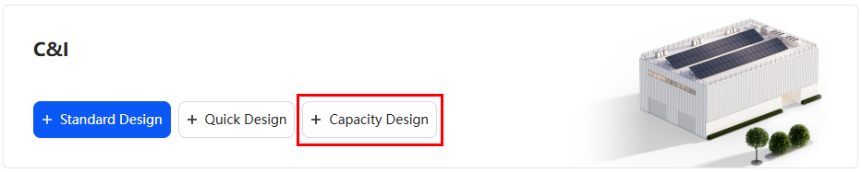

Capacity Design (Old Version)
The following figure shows the process of creating a capacity design project and generating a report.

Entering Basic Information
The basic information includes the PV plant location and weather station.
- Enter the project name, and set basic information such as the address of the PV plant, weather station, and project lifecycle based on site requirements.
- Project Lifecycle indicates the period from the start to the end of a project. The period ranges from 5 to 30 years.
- If no weather stations provided by the system meet the requirements, click to upload the meteorological data. For details about the upload requirements, see 7.4 How Do I Import Meteorological Data?
- Set the on-grid/off-grid mode and related parameters for the project. The system supports three modes: on-grid, on/off-grid, and off-grid.
- Press and hold in the map area and move the pointer to the location where you want to install the PV plant.
- Click Next to save the settings.

Electricity Price and Consumption Settings
After parameters such as the electricity price and energy consumption load are set, the system calculates the revenue and self-consumption of a PV plant system based on the energy consumption.
Electricity Price Settings
To configure ESSs and ensure the accuracy of benefit calculation, set the effective electricity price and related parameters in Electricity Price Settings as required.
- Click Set and select a currency unit as required.
- Set Feed-in Tariff.
- Set Purchase Price.
Set parameters such as Maximum Demand Mode, Monthly Demand Charge, and Volumetric Charge Type as required.
Parameter | Description
Maximum Demand Mode | Set the settlement period of the maximum demand charge. The statistics can be collected by year, month, or time period.
Monthly Demand Charge | The basic demand charges are calculated based on the maximum demand statistical period and are converted into monthly electricity bills.
Volumetric Charge Type | The volumetric charge type can be set to Fixed or Time-of-Use.

If you want to set a time-of-use electricity price, set Volumetric Charge Type to Time-of-Use. For details, see 7.1 How Do I Set the Time-of-Use Electricity Prices?
If a price template has been configured in the Management System, you can select User-Defined Input or Template Input as required.
If no price templates have been configured in the Management System, you can set Maximum Demand Mode, Monthly Demand Charge, and Volumetric Charge Type based on the actual situation.
- Set Electricity Price Growth Rate.
In the off-grid mode, you need to set Off-grid Electricity Price only.
Consumption Settings
- Creating an energy consumption model through model generation
  - Set Type to Generate Model.
  - Set Annual Energy Consumption and Monthly Energy Consumption as required.
  - Set Workday Model and Weekend Model as required. The system displays the daily load curve based on Workday Model and Weekend Model.
  - Optional: If the preconfigured models do not meet your requirements, set Workday Model or Weekend Model to Custom and click to edit the model.
  - Select a type of consumption growth rate and set related parameters based on site requirements.
- Creating an energy consumption model by importing data
  - Set Type to Data Import.
  - Click Download Template, enter the load data in the template as required, and save the template. For details, see 7.2 How Do I Generate an Energy Consumption Model by Importing Data?
  - Click Add File, and select and upload the saved template.
  - Select a type of consumption growth rate and set related parameters based on site requirements.
- If no load is connected, set Annual Energy Consumption to 0.
- If you need to configure ESSs, set valid electricity prices and loads first.
Maximum Load Surge Power Settings
In the off-grid and on/off-grid modes, you need to set the maximum surge power for all surge loads.
Load Shedding Model Settings
In the off-grid and on/off-grid modes, you need to set the load shedding model and set related parameters based on the site requirements.
- In the off-grid mode, you can set Maximum Load Shedding Ratio only.
- In the on/off-grid mode, you can set Maximum Load Shedding Ratio, load shedding models, and other parameters.

Plan Settings
Plan Settings and PV System Settings
- On-grid mode and on/off-grid mode
- A PV system is available.
    - Select Enable PV, select PV+ESS Operating Mode as required, and set parameters such as Planning Objective.
PV+ESS Operating Mode | Description
Maximum Self-Consumption | PV energy is supplied preferentially to loads, and surplus PV energy is used to charge the ESS. If the ESS is fully charged or is being charged at full power, the surplus PV energy is fed to the grid. When PV energy is insufficient or cannot be generated at night, the ESS discharges energy to loads. This improves the self-consumption rate and energy self-sufficiency rate, and reduces electricity costs.
Maximum Self-Consumption+TOU | PV energy is supplied preferentially to loads, and surplus PV energy is used to charge the ESS. The ESS is charged and discharges energy based on the TOU policy. That is, the ESS is charged based on the maximum charge power calculated by the algorithm during the charge period. In the No Charge or Discharge period, the surplus PV energy is used to charge the ESS.
Maximum Self-Consumption+Peak Shaving | PV energy is supplied preferentially to loads, and surplus PV energy is used to charge the ESS. In the ESS charge period, the power obtained from the grid is controlled based on the demand calculated by the algorithm. In the No Charge or Discharge period, the surplus PV energy is used to charge the ESS.
Maximum Self-Consumption+TOU+Peak Shaving | PV energy is supplied preferentially to loads, and surplus PV energy is used to charge the ESS. The ESS is charged and discharges energy based on the TOU policy. That is, in the ESS charge period, the charge power is controlled based on the demand calculated by the algorithm. In the No Charge or Discharge period, if the sum of the power from the grid plus the PV power does not meet the consumption requirements according to the peak shaving rule, the ESS discharges if it has energy so that the grid can obtain power from the ESS.

    - Set PV parameters as required.
    - If no existing PV system is available, set Existing PV Project to No, and configure PV Capacity Planning Mode, PV module manufacturer, PV module model, and inverter model as required.
    - If an existing PV system is available, set Existing PV Project to Yes and set Load Data Type as required. If Total Load is selected, set parameters such as the PV capacity, PV module manufacturer, PV module model, and inverter model. If Net Load is selected, negative values can be imported in the load data import template.
- No PV system is available.
There is no need to select Enable PV. Set parameters such as ESS Operating Mode and Planning Objective as required.
ESS Operating Mode | Description
TOU | The system controls the battery charge and discharge time segments to reduce energy consumption costs. For example, if you set the low electricity price period at night as the charge period, the system charges the ESS at the maximum power in this period. If you set the high electricity price period as the discharge period, the ESS can discharge energy only during the discharge period based on the actual load power.
Peak Shaving | Lower the peak demand power purchased from the grid during peak hours, reducing electricity fees.
TOU+Peak Shaving | The ESS is charged and discharges energy based on the TOU policy. That is, in the ESS charge period, the charge power is controlled based on the demand calculated by the algorithm. In the No Charge or Discharge period, if the power from the grid does not meet the consumption requirements according to the peak shaving rule, the ESS discharges if it has energy so that the grid can obtain power from the ESS.

- Off-grid mode
In the off-grid mode, PV is enabled by default. Set Planning Objective and PV system parameters based on site requirements.
- Click to add a customized PV module model.
- Click Frequently Used PV Module to set the frequently used PV module models. For details, see 6.2 Setting Frequently Used PV Modules.
ESS Settings
Set parameters such as ESS Capacity Planning Mode and ESS Type as required.
- When ESS Capacity Planning Mode is set to Specified ESS Capacity:
  - Set ESS Type as required.
  - Click Add Device and set the ESS model and quantity as required.
- When ESS Capacity Planning Mode is set to Recommended ESS Capacity.
Set ESS Type as required. The system automatically recommends an appropriate ESS.
If PV is enabled and PV+ESS Operating Mode is set to Maximum Self-Consumption+TOU or Maximum Self-Consumption+TOU+Peak Shaving, or if PV is disabled and ESS Operating Mode is set to TOU or TOU+Peak Shaving, you can set the ESS policy as required. If you select Custom, you can configure the following items:
- Click Create to set the monthly charge or discharge time range.
- Click Copy to copy the existing configuration.
- Click Add Time Range to add a time range for charge or discharge.
Communications Device Settings
You can determine whether to select Communications Device. If it is selected, the system recommends its Type and Model. You can also modify the type and model as required.
Meter Settings
You can determine whether to select Meter. If it is selected, the system recommends its Type. You can also modify the type as required.
Genset System Settings
In the off-grid and on-grid modes, you can choose whether to set Enable Genset.
- Click to view the genset specifications.
- Click to add a customized genset model.
- If a genset model is followed by , the genset model is customized.
Advanced Settings
- PV System Settings
If PV is enabled, to edit parameters such as Service Life and Azimuth for PV modules, click Edit on the right.
- ESS Settings
To edit parameters such as End-of-Charge SOC, End-of-Discharge SOC, and RTE for the ESS, click Edit on the right.
- ESS Degradation
When the ESS is running, the battery state of health (SOH), which means the ratio of the actual ESS capacity to the rated ESS capacity, is being degraded continuously. To edit the ESS degradation type, click Edit on the right.

Economic Settings
After determining the design of inverters, PV modules, and ESSs, you can analyze the PV benefits.
Cost Settings
- Click Set to set the discount rate as required.
- In Initial Installation Cost, enter the price based on the site requirements.
- In O&M Cost, enter the O&M cost based on site requirements.
You need to set genset parameters for the on/off-grid and off-grid modes.
Investment Settings
In the on-grid mode, if you have not enabled PV and set the investment mode to share revenue with investors, you can select Share Revenue with Investor and set investment-related parameters.
The investment settings are not supported in the on/off-grid and off-grid modes.
Loan Settings
If you have a loan, select Loan Involved and set Loan Ratio, Max Loan Amount, and other parameters.
Government Subsidy Settings
If local government subsidies are available, set government subsidies for better economic analysis.
- Click Add Government Subsidy.
- Select a subsidy type and set the subsidy amount and other parameters as required.
- Click Next to generate a report.

Generating a Report
After a report is generated, the system provides information such as the ROI and energy consumption based on the design scheme. You can customize report contents or export the report.
Report Details
The report contains multiple parts, such as Basic Info, Project Overview, Electricity Bills Analysis, and Economic Benefits. Click Custom and select the parts to be displayed in the report. For details about the parameters in the report, see 8.2 Report Parameters.
Basic Info: displays the project name and address in the design scheme.
Project Overview: displays the system capacity and device list in the design scheme.
Economic Benefits: displays the expected economic benefits and return on investment (ROI) of the design scheme in the future, and compares the benefits under various ESS capacities with those under the optimal ESS capacity.
Electricity Bills Analysis: displays the electricity bills comparison before and after PV+ESS or ESS installation.
Energy Management: displays the detailed energy distribution in the scheme.
ESS Configuration Policy: displays the operating mode, charge and discharge configuration policy, RTE, and battery degradation curve of the ESSs.
Networking Diagram: displays the networking diagram of devices.
Power Curve: displays the comparison of the grid power before and after PV+ESS or ESS installation in each month of a year, the charge and discharge power in a day, and the electricity price curve.
- You can select a day to view the charge and discharge power curve on that day. The exported report shows the statistics on the day you select.
- When the PV+ESS operating mode is maximum self-consumption, the charge and discharge configuration policies are not displayed in the ESS Configuration Policy area.
ESS Benefits: displays the benefits when the ESS type is liquid-cooled ESS. The benefits of Huawei's ESSs include C2C dual-link safety, LCOS, and flexible application in all scenarios.
First-Year Environmental Benefits: displays the statistics of the scheme's contributions to energy saving and emission reduction.
Simulation Parameters: is used to calculate the simulated energy yield.
- If the values of the PV capacity and ESS capacity, number of PV modules, and number of inverters are 0 in the report, you are advised to check whether the purchase price, load, and recommended maximum PV capacity are properly set based on the actual situation.
- If the values of economic parameters such as the payback period are 0 in the report, you are advised to check whether the PV+ESS system price and O&M cost are properly set based on the actual situation.
Exporting a Report
On the Report page, click Export Report.
Sharing a Report
On the Report page, click Share Report. In the Share Report dialog box, copy the static report link and share the generated report.
By default, the report sharing link is open and valid for six months. To set the sharing link, perform the following operations:
- In the Share Report dialog box, click Set Permissions.
- Set the validity period of the sharing link and whether to allow sharing. When Share is disabled, the static report content cannot be viewed.

Capacity Design (New Version)
On the basic information page, click New Version in the upper right corner. The new process for creating a capacity design project is as follows.


Basic Information
The basic information includes the PV plant location, weather station, and grid information.
            - Set the basic information.
- Enter the project name, and set basic information such as the address of the PV plant, weather station, and project lifecycle based on site requirements.
- Project Lifecycle indicates the period from the start to the end of a project. The period ranges from 5 to 30 years.
- If no weather stations provided by the system meet the requirements, click to upload the meteorological data. For details about the upload requirements, see 7.4 How Do I Import Meteorological Data?
- Select the project type and scenario as required.
- Press and hold in the map area and move the pointer to the location where you want to install the PV plant.
            - Set the grid information.
- Select the grid connection mode.
- (Optional) Set Feed-in Power Upper Limit and Operation Mode as required.
            - Click Next to save the settings.
----End
- To return to the old version, click Old Version in the upper left corner before clicking Next.

Electricity Price & Consumption
After the electricity price and load parameters are set, the system calculates the revenue after the ESS installation based on the electricity consumption.
Electricity Price Settings
To set the currency unit and electricity price growth rate, click Advanced Settings.
- Set Feed-in Tariff.
- Set Purchase Price.
- Select User-Defined Input in Type.
    - Set Volumetric Charge Type and the electricity price as required.
            - If you want to set a time-of-use electricity price, set Volumetric Charge Type to Time-of-Use. For details, see 7.1 How Do I Set the Time-of-Use Electricity Prices?
    - Set the demand charge rate as required.
    - If you set the demand charge rate to By Actual Demand, you need to set parameters such as Maximum Demand Mode and Monthly Demand Charge.
    - If you set the demand charge rate to Transformer Capacity, you need to set parameters such as Transformer Capacity and Price.
Parameter | Description
Maximum Demand Mode | Set the settlement period of the maximum demand charge. The statistics can be collected by year, month, or time period.
Monthly Demand Charge | The basic demand charges are calculated based on the maximum demand statistical period and are converted into monthly electricity bills.
Volumetric Charge Type | The volumetric charge type can be set to Fixed or Time-of-Use.

- Select Template Input in Type.
    - Click Select Template.
    - Select the required template and click OK.
- If a price template has been configured in the Management System, the Template Input option is provided for the electricity purchase price type. You can select the option as required.
- If the price template does not meet the requirements, you can configure a template in the Management System.
- Set Type to Data Import.
    - Click Download Template, enter the load data in the template as required, and save the template.
    - Click Add File, and select and upload the saved template.
- Set Purchase Price.
  - Set the volumetric charge rate as required.
  - Set the parameters related to the volumetric charge rate by user-defined input.
      - Select User-Defined Input in Type.
      - Set Volumetric Charge Type and the electricity price as required.
If you want to set a time-of-use electricity price, set Volumetric Charge Type to Time-of-Use. For details, see 7.1 How Do I Set the Time-of-Use Electricity Prices?
  - Set the parameters related to the volumetric charge rate by data import.
      - Set Type to Data Import.
      - Click Download Template, enter the electricity price data in the template as required, and save the template.
      - Click Add File, and select and upload the saved template.
  - Set the demand charge rate as required.
  - If you set the demand charge rate to By Actual Demand, you need to set parameters such as Maximum Demand Mode and Monthly Demand Charge.
  - If you set the demand charge rate to Transformer Capacity, you need to set parameters such as Transformer Capacity and Price.
Parameter | Description
Maximum Demand Mode | Set the settlement period of the maximum demand charge. The statistics can be collected by year, month, or time period.
Monthly Demand Charge | The basic demand charges are calculated based on the maximum demand statistical period and are converted into monthly electricity bills.
Volumetric Charge Type | The volumetric charge type can be set to Fixed or Time-of-Use.

Consumption Settings
- Creating an energy consumption model through model generation
  - Set Type to Generate Model.
  - Set Annual Energy Consumption and Monthly Energy Consumption as required.
  - Set Workday Model and Weekend Model as required. The system displays the daily load curve based on Workday Model and Weekend Model.
  - Optional: If the preconfigured models do not meet your requirements, set Workday Model or Weekend Model to Custom and click to edit the model.
  - Select a type of consumption growth rate and set related parameters based on site requirements.
- Creating an energy consumption model by importing data
  - Set Type to Data Import.
  - Click Download Template, enter the load data in the template as required, and save the template. For details, see 7.2 How Do I Generate an Energy Consumption Model by Importing Data?
  - Click Add File, and select and upload the saved template.
  - Select a type of consumption growth rate and set related parameters based on site requirements.

System & Cost
When you access the System & Cost module for the first time, a dialog box is displayed prompting you to set the system and cost parameters.
PV
Set the PV module model, inverter model, target capacity ratio, and PV O&M cost as required.
- If the frequently used PV module does not meet your requirements, click Frequently Used PV Module to access the Frequently Used PV Modules setting page and add one.
ESS
Set ESS Type, ESS Operating Mode, and ESS Price as required.
ESS Operating Mode | Description
Maximum Self-Consumption | PV energy is supplied preferentially to loads, and surplus PV energy is used to charge the ESS. If the ESS is fully charged or is being charged at full power, the surplus PV energy is fed to the grid. When PV energy is insufficient or cannot be generated at night, the ESS discharges energy to loads. This improves the self-consumption rate and energy self-sufficiency rate, and reduces electricity costs.
TOU | PV energy is supplied preferentially to loads, and surplus PV energy is used to charge the ESS. The ESS is charged and discharges energy in accordance with the TOU policy. That is, the ESS is charged based on the maximum charge power calculated by the algorithm during the charge period. In the No Charge, No Discharge period, the surplus PV energy is used to charge the ESS.
TOU+Peak Shaving | PV energy is supplied preferentially to loads, and surplus PV energy is used to charge the ESS. The ESS is charged and discharges energy in accordance with the TOU policy. That is, in the ESS charge period, the charge power is controlled based on the demand calculated by the algorithm. During the No Charge, No Discharge period, if the sum of grid and PV power does not meet the consumption requirements, the ESS discharges if it has energy so that the grid can obtain power from the ESS.

Communication Components and Meters
Set Communication Component Model and Meter Model as required.
Economic Settings
You can set parameters related to investment, loan, or government subsidy policies, if applicable.
Advanced Settings
You can click Advanced Settings to set parameters such as PV System, ESS, ESS Degradation, and Economic Parameters.
- PV System: Select a PV system to set the service life, azimuth, and other parameters of PV modules.
- ESS: Select an ESS to set the end-of-charge/discharge SOC, RTE, and other parameters of the ESS.
- ESS Degradation: Select ESS Degradation to set the degradation type and related parameters as required.
- Economic Parameters: Select Economic Parameters to set the discount rate, investment parameters, and other related parameters.
Calculation Results
The system calculates the capacity scheme based on the basic information, electricity price, load parameters, and cost parameters.
- Click Design Capacity and set Planning Objective and Baseline IRR as required.
- Click OK. The system calculates the capacity scheme.
- Click Calculate All. The system further calculates the economic benefits and energy data.
- Click Next to save the result.
- Click to edit an existing scheme as required.
- Click to delete an existing scheme.
- Click  to add a scheme.

Report
In the report module, you can compare the investment return and energy data of multiple schemes in cards, tables, and charts.
Overview
You can view the optimal economic benefit indicators of each scheme.
Report Table
You can view the detailed information about multiple design schemes in the table, covering parameters such as system capacity, economic benefits, and energy management, and compare the technical features and economic effects of different design schemes.
- Click to view the scheme report details.
- Interpreting a scheme report
Parameter | Description | Remarks
Basic Info | Displays the project name and address in the design scheme.
Project Overview | Displays the system capacity and device list in the design scheme.
Economic Benefits | Displays the expected economic benefits and return on investment (ROI) of the design scheme in the future, and compares the benefits under various ESS capacities with those under the optimal ESS capacity.
Electricity Bills Analysis | Displays the electricity bills comparison before and after PV+ESS or ESS installation.
Energy Management | Displays the detailed energy distribution in the scheme.
ESS Configuration Policy | Displays the operating mode, charge and discharge configuration policy, RTE, and battery degradation curve of the ESSs. | When the PV+ESS operating mode is maximum self-consumption, the charge and discharge configuration policies are not displayed in the ESS Configuration Policy area.
Networking Diagram | Displays the networking diagram of devices.
Power Curve | Displays the comparison of the grid power before and after PV+ESS or ESS installation in each month of a year, the charge and discharge power in a day, and the electricity price curve. | You can select a day to view the charge and discharge power curve on that day. The exported report shows the statistics on the day you select.
ESS Benefits | Displays the benefits when the ESS type is liquid-cooled ESS. The benefits of Huawei's ESSs include C2C dual-link safety, LCOS, and flexible application in all scenarios.
First-Year Environmental Benefits | Displays the statistics of the scheme's contributions to energy saving and emission reduction.
Simulation Parameters | Is used to calculate the simulated energy yield.

- If the values of the PV capacity, ESS capacity, number of PV modules, or number of inverters are 0 in the report, you are advised to check whether the purchase price, load, and recommended maximum PV capacity are properly set based on the actual situation.
- If the values of economic parameters such as the payback period are 0 in the report, you are advised to check whether the PV+ESS system price and O&M cost are properly set based on the actual situation.
- Switching schemes: Click the drop-down list in the upper right corner to switch schemes.
- Customizing a report: Click Custom to select the parts that need to be displayed in the report. For details about the parameters in the report, see 8.2 Report Parameters.
- Exporting a report: Click Export Report to export the report of this scheme.
- Sharing a report
Click Share Report. In the Share Report dialog box, copy the static report link and share the generated report.
By default, the report sharing link is open and valid for six months. To set the sharing link, perform the following operations:
    - In the Share Report dialog box, click Set Permissions.
    - Set the validity period of the sharing link and whether to allow sharing. When Share is disabled, the static report content cannot be viewed.
Report Chart
You can view the economic indicators in the chart to compare the economic benefits of different schemes.

More Settings

Custom PV Modules
The system has preset common PV module information templates. If the preset templates cannot meet user requirements, you can customize PV module information templates.
User interfaces displayed in this section are for reference only. The actual user interfaces may vary by software versions.
Creating a Custom PV Module
Click the avatar in the upper right corner, choose Personal Settings from the drop-down list, and choose Custom PV Modules > Create.
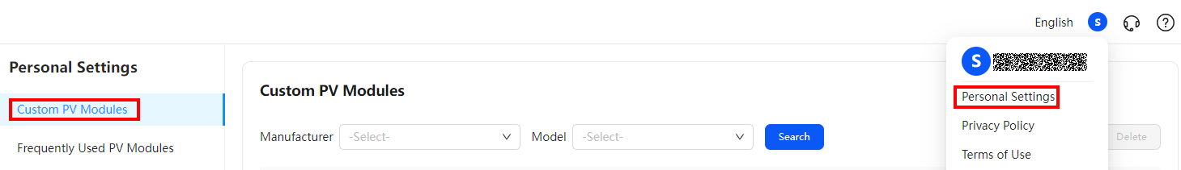
- Setting PV module parameters
- Set PV module parameters, such as Maximum Power (Pmax) [W] and Length (mm), according to the PV module brochure or related specifications. For details about how to obtain the values of Solar Cells Connected in Series and Solar Cells Connected in Parallel, see Obtaining Solar Cell Parameters.
- You can click Copy Existing Module to import the preset module template.
- You can click Import PAN File to import the local module template and modify related parameters as required.
- (Optional) Uploading a PV module to the module library
If you want to upload a PV module to the module library, select Add to Module Library and set Specification Website. After the application is approved by the administrator, Archived is displayed in the Status column, indicating that the PV module has been successfully uploaded to the module library and the PV module information will be available to all users.
- Click Save.
- For details about the PV module brochure, specification website, or related specifications, contact the PV module vendor.
- Set parameters in the standard test conditions (STC) scenario.
- Check the unit of each parameter to avoid errors caused by inconsistent units.
The following uses the PV module of a vendor as an example:
              - PV module brochure
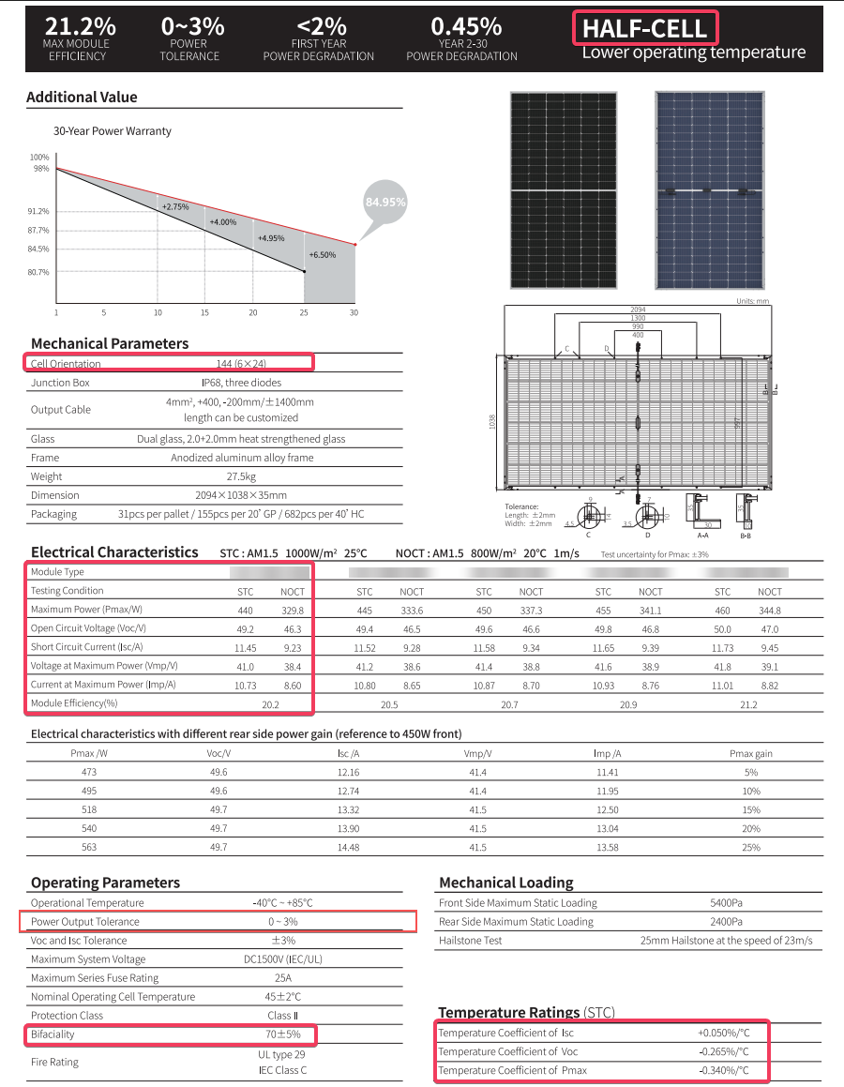

              - Setting PV module parameters
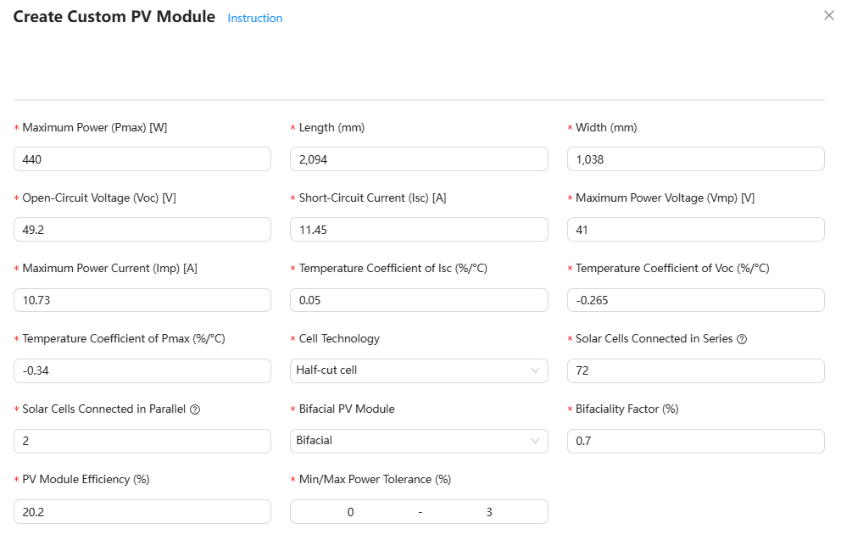

Obtaining Solar Cell Parameters
You can obtain the values of Solar Cells Connected in Series and Solar Cells Connected in Parallel using either of the following methods:
- Method 1: Contact the module vendor.
- Method 2: Perform calculation according to the following steps.
  - Calculate Solar Cells Connected in Series.
Solar Cells Connected in Series = Maximum Power Voltage/MPP voltage of a single solar cell
  - Calculate Solar Cells Connected in Parallel.
Solar Cells Connected in Parallel = Number of Cells/Solar Cells Connected in Series. The value of Number of Cells can be obtained from the brochure.
- MPP voltage of a single solar cell: The value is related to the hardware materials. For example, the recommended MPP voltage of a monocrystalline silicon solar cell is 0.45–0.65 V.
- The value of Solar Cells Connected in Series shall be the maximum integer in the value range.
- The value of Solar Cells Connected in Parallel shall be an integer.
Other Operations
- To view PV module parameters, click in the Operation column.
- To modify the parameters of a custom PV module, click in the Operation column.
- To delete a custom PV module, click in the Operation column.
- You can view the processing status of the PV module application in the Status column. If the status is Rejected, click to view the rejection reason.

Setting Frequently Used PV Modules
If you want to display frequently used PV modules by default when you set PV modules, you can set it on the Frequently Used PV Modules page.
Setting Frequently Used PV Modules
- Click the avatar in the upper right corner and choose Personal Settings from the drop-down list.
- Choose Frequently Used PV Modules.
- Select Display Frequently Used PV Modules by Default.
Other Operations
- If you want to use a specified PV module by default when creating a project, set the button in the Preference column of the PV module model to . Only one Preference can be set at a time.
- Click Add Frequently Used PV Module to add a new frequently used PV module model.
- Click in the Operation column to view the PV module specifications.
- Click in the Operation column to delete the frequently used PV module model.

Genset Configuration
Common genset models have been preset in the system. If the preset models cannot meet your requirements, you can set Genset Configuration to customize genset models.
Adding a Genset Model
- Click the avatar in the upper right corner and choose Personal Settings from the drop-down list.
- Choose Genset Configuration > Create.
- Set parameters such as Manufacturer, Model, and Rated Power. Click Import Genset Parameter to import the preset genset model template, and change related parameters as required.
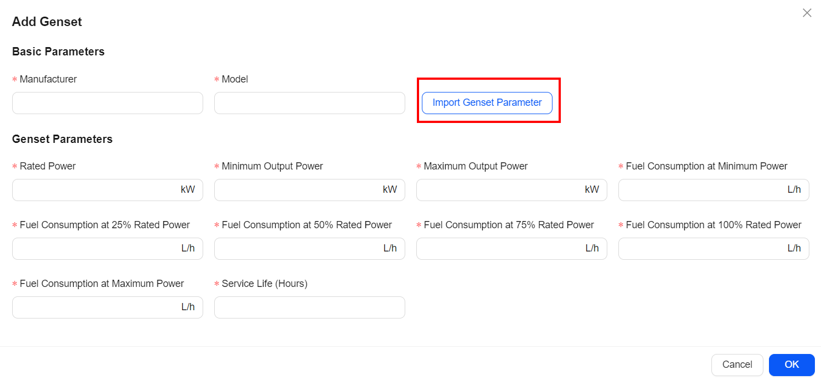
Other Operations
- To view genset specifications, click in the Operation column.
- To modify genset specifications, click in the Operation column.
- To delete a genset model, click in the Operation column, or select genset models in batches and click Delete.

Economic Settings
You can set the default values of basic economic parameters in Economic Settings.
- Set Currency Unit, Discount Rate, Pay Tax, and Tax Rate as required.
- Click Save.

Report Cover Settings
After the company name and logo are set, they are displayed in the online report and exported report.
- Set Company Name.
- Upload the company logo. You can modify and delete the uploaded logo.

FAQs

How Do I Set the Time-of-Use Electricity Prices?
If the electricity prices vary with time segments in a day, you can set the time-of-use electricity prices based on the site requirements.
Procedure
- On the Electricity Price & Consumption page, set Volumetric Charge Type to Time-of-Use.
- Select the month for which you want to set the time-of-use electricity prices.
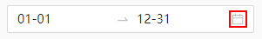
You can set multiple date ranges for the time-of-use electricity prices. You can click Add Date Range to add a date range. The date ranges must cover an entire year from January 1 to December 31 and cannot overlap.
- Click and add a time-of-use electricity price based on the site requirements.
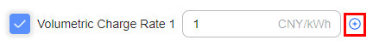
- Set Volumetric Charge Rate and click the corresponding time segment.
- You can drag adjacent time segments to set them in batches.
- Multiple time segments can be set for each date range. The time segments must cover an entire day from 00:00:00–24:00:00.

How Do I Generate an Energy Consumption Model by Importing Data?
The system provides preset typical energy consumption models. You can also import load data to generate energy consumption models. In this way, the system will analyze load data in the past year and provide more accurate system design suggestions.
Filling in the Energy Consumption Template
- Click Download Template in the Data Import area.
- Select a desired template based on site requirements.
- Fill in the load data of one year based on site requirements.
- Do not delete this note or change the format, time row, date column, or time interval in the template. Enter the load power or load consumption for each time segment in each date. Do not leave any cell empty.
- The template contains all data from 0:00 on January 1 to the end of the year (365 days).
- The load power can be measured in kW or W. The energy can be measured in kWh. Select either unit based on site requirements.
- Take the "Time in Row; Date in Column" template with an interval of 60 minutes as an example. Enter the load power or energy at 0:00 in column B, the load power or energy at 1:00 in column C, and so on.
- Each value must be greater than or equal to 0. If you set the unit to kW or kWh, you can enter a maximum of six decimal places for each value. If you set the unit to W, you can enter a maximum of two decimal places for each value.
              - Correct example
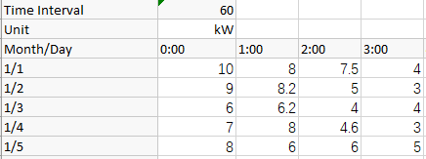

              - Incorrect example
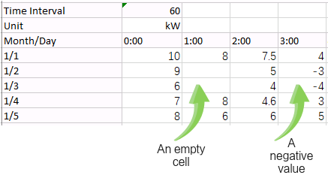

Generating an Energy Consumption Model
User interfaces displayed in this section are for reference only. The actual user interfaces may vary by software versions.
- Click Add File in the Data Import area.
- Select and upload the filled load data template. The system generates an energy consumption model based on the input load data.
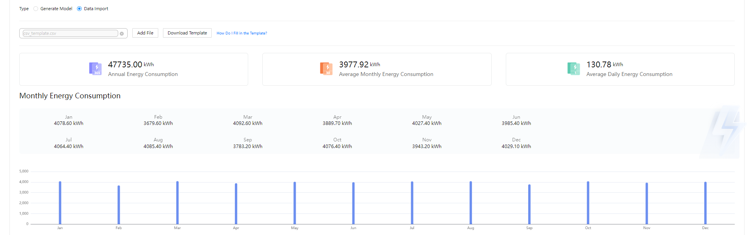
Exception Handling
When you enter the 24-hour load data in a column with separators in the load data template, as shown in Figure 7-3, you can sort out the data in columns by referring to Figure 7-4.
              - Exception example
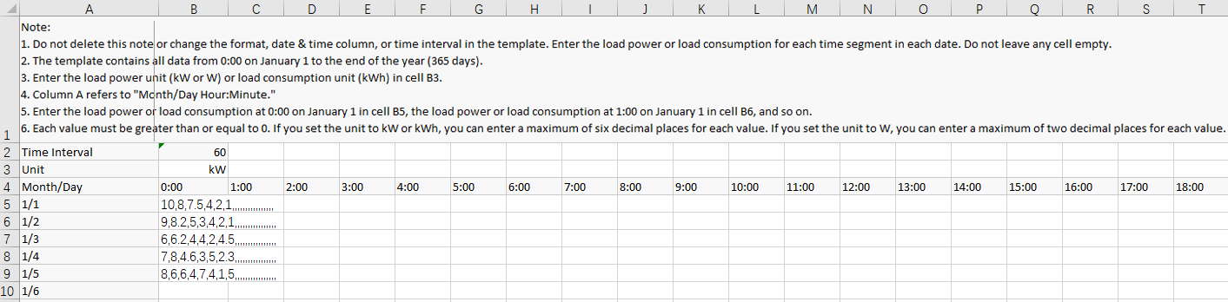

              - Convert text to columns wizard
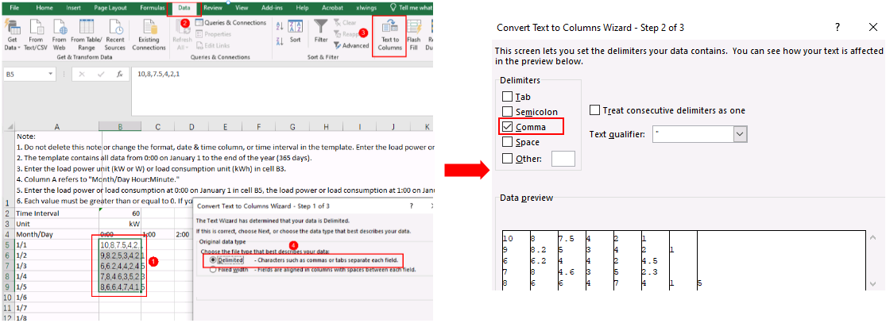

What Shall I Do When Operations on the PV Module Layout Fail?
Symptom
Symptom 1: In the PV module layout, the region attribute settings fail to apply.
Symptom 2: After editing a PV module, there is no response from multiple cancel operations by pressing Ctrl+Z.
Possible Cause
Hardware acceleration is not enabled for the browser. Enable it and try again.
Solution
- For a Chrome browser, perform the following steps to enable hardware acceleration:
  - Enter chrome://settings/system in the address box of the Chrome browser and press Enter.
  - Choose Settings > System and enable Use hardware acceleration when available.
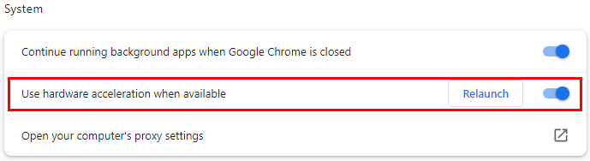
- For a Firefox browser, enter https://support.mozilla.org/en-US/kb/performance-settings in the address box and enable hardware acceleration accordingly.

How Do I Import Meteorological Data?
In addition to the preset meteorological data, this design tool also allows you to import meteorological data from other sources.
- If you select Upload Meteorological Data, download the data from the official website of Solargis or Meteonorm. For details, see the operation guide on the corresponding official website.
- If the software cannot be used due to software viruses in the imported file or security attacks, this design tool will not assume any legal responsibility. You need to take security precautions.
1. On the Weather Station page, click .
2. Select a data type and upload the corresponding data file. The file requirements are as follows:
- If Solargis_TMY_P50_PT60M is selected, the TMY 60-minute P50 data file in .csv format can be uploaded. For details about the data format, see Figure 7-5.
              - Solargis_TMY_P50_PT60M data format
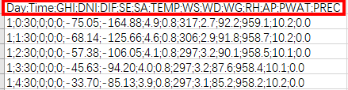

- If Meteonorm_TMY3_Hour is selected, the TMY3 data file in .csv format exported from Meteonorm can be uploaded. For details about the data format, see Figure 7-6.
              - Meteonorm_TMY3_Hour data format

- If Meteonorm_User_Defined_Hour is selected, the user-defined data file in .csv format exported from Meteonorm can be uploaded. For details about the data format, see Figure 7-7.
              - Meteonorm_User_Defined_Hour data format
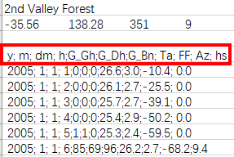

Reference Information

Residential Solution Overview
Device Model Description
Scenario | Model
PV-only (on-grid) | - L1: SUN2000-2/3/3.68/4/4.6/5/6KTL-L1  - LC0: SUN2000-8/10K-LC0  - LB0: SUN2000-3/3.68/4/4.6/5/6K-LB0  - SUN5000-LB0: SUN5000-3/6K-LB0  - M1: SUN2000-3/4/5/6/8/10/12KTL-M1/SUN2000-10KTL-BEM1  - M2: SUN2000-8/10/12/15/17/20KTL-M2  - M5: SUN2000-12/15/17/20/25KTL-M5  - MB0: SUN2000-12/15/17/20/25K-MB0  - SUN5000-MB0: SUN5000-17/25K-MB0  - MAP0: SUN2000-5/6/8/10/12KTL-MAP0/SUN2000-10K-MAP0-BE  - SUN5000-MAP0: SUN5000-8/12K-MAP0  - LB0-NH: SUN2000-4.95K-LB0-NH  - SUN5000-LB0-NH: SUN5000-4.95K-LB0-NH  - MBL0: SUN2000-6/10/15K-MBL0  - SmartAssistant: SA4H-A02  - Smart Dongle: SDongleA-05 (WLAN-FE), SDongleB-06 (4G+WLAN AP)  - Smart Power Sensor: DDSU666-H (Single-Phase); DTSU666-H 100A (Three-Phase)
PV+ESS (on-grid) | - L1: SUN2000-2/3/3.68/4/4.6/5/6KTL-L1  - LC0: SUN2000-8/10K-LC0  - LB0: SUN2000-3/3.68/4/4.6/5/6K-LB0  - SUN5000-LB0: SUN5000-3/6K-LB0  - M1: SUN2000-3/4/5/6/8/10/12KTL-M1/SUN2000-10KTL-BEM1  - M2: SUN2000-8/10/12/15/17/20KTL-M2  - M5: SUN2000-12/15/17/20/25KTL-M5  - MB0: SUN2000-12/15/17/20/25K-MB0  - SUN5000-MB0: SUN5000-17/25K-MB0  - MAP0: SUN2000-5/6/8/10/12KTL-MAP0/SUN2000-10K-MAP0-BE  - SUN5000-MAP0: SUN5000-8/12K-MAP0  - LB0-NH: SUN2000-4.95K-LB0-NH  - SUN5000-LB0-NH: SUN5000-4.95K-LB0-NH  - MBL0: SUN2000-6/10/15K-MBL0  - SmartAssistant: SA4H-A02  - Smart Dongle: SDongleA-05 (WLAN-FE), SDongleB-06 (4G+WLAN AP)  - Smart Power Sensor: DDSU666-H (Single-Phase); DTSU666-H 100A (Three-Phase)  - SmartLogger: SmartLogger3000A  - SmartGuard: SmartGuard-63A-S0, SmartGuard-63A-T0  - ESS: LUNA2000-(5-30)-S0, LUNA2000-(7-42)-S1, LUNA2000-5/7/10/12/14/15/17/19/21-S1
PV+ESS (on/off-grid) | - L1: SUN2000-2/3/3.68/4/4.6/5/6KTL-L1  - LC0: SUN2000-8/10K-LC0  - LB0: SUN2000-3/3.68/4/4.6/5/6K-LB0  - SUN5000-LB0: SUN5000-3/6K-LB0  - M1: SUN2000-3/4/5/6/8/10/12KTL-M1/SUN2000-10KTL-BEM1  - MB0: SUN2000-12/15/17/20/25K-MB0  - SUN5000-MB0: SUN5000-17/25K-MB0  - MAP0: SUN2000-5/6/8/10/12KTL-MAP0/SUN2000-10K-MAP0-BE  - SUN5000-MAP0: SUN5000-8/12K-MAP0  - LB0-NH: SUN2000-4.95K-LB0-NH  - SUN5000-LB0-NH: SUN5000-4.95K-LB0-NH  - SmartGuard: SmartGuard-63A-S0, SmartGuard-63A-T0  - ESS: LUNA2000-(5-30)-S0, LUNA2000-(7-42)-S1, LUNA2000-5/7/10/12/14/15/17/19/21-S1

PV-only (on-grid)
Networking | Single/Three-phase | Inverter Qty. | Inverter |  |  | Optimizer |  |  | Meter
Networking | Single/Three-phase | Inverter Qty. | Inverter 1 | Inverter 2 | Inverter 3 | SUN2000-450W-P2 or SUN2000-600W-P | MERC-600W-PA0 | MERC-1100W-P or MERC-1300W-P | Meter
SmartAssistant | Single-phase | 1 | L1/LC0/LB0/SUN5000-LB0 |  |  | √ | √ | × | ×
SmartAssistant | Single-phase | 2 | L1/LC0/LB0 | L1/LC0/LB0 |  | √ | √ | × | ×
SmartAssistant | Single-phase | 2 | SUN5000-LB0 | SUN5000-LB0 |  | √ | √ | × | ×
SmartAssistant | Single-phase | 3 | L1/LC0/LB0 | L1/LC0/LB0 | L1/LC0/LB0 | √ | √ | × | ×
SmartAssistant | Single-phase | 3 | SUN5000-LB0 | SUN5000-LB0 | SUN5000-LB0 | √ | √ | × | ×
SmartAssistant | Three-phase | 1 | M1/M2/M5/MB0/MAP0/SUN5000-MB0/SUN5000-MAP0 |  |  | √ | √ (Not supported by M2/M5) | √ (Not supported by M1/MAP0/SUN5000-MAP0) | ×
SmartAssistant | Three-phase | 1 | SUN2000-10KTL-BEM1/SUN2000-10K-MAP0-BE |  |  | × | √ | × | ×
SmartAssistant | Three-phase | 1 | MBL0 |  |  | × | × | × | ×
SmartAssistant | Three-phase | 2 | M1/M2/M5/MB0 | M1/M2/M5/MB0 |  | √ | √ (Not supported by M2/M5) | √ (Not supported by M1) | ×
SmartAssistant | Three-phase | 2 | MAP0 | MAP0 |  | √ | √ | × | ×
SmartAssistant | Three-phase | 2 | SUN5000-MB0 | SUN5000-MB0 |  | √ | √ | √ | ×
SmartAssistant | Three-phase | 2 | SUN5000-MAP0 | SUN5000-MAP0 |  | √ | √ | × | ×
SmartAssistant | Three-phase | 2 | MBL0 | MBL0 |  | × | × | × | ×
SmartAssistant | Three-phase | 2 | SUN2000-10KTL-BEM1 | SUN2000-10KTL-BEM1 |  | × | √ | × | ×
SmartAssistant | Three-phase | 2 | SUN2000-10K-MAP0-BE | SUN2000-10K-MAP0-BE |  | × | √ | × | ×
SmartAssistant | Three-phase | 3 | M1/M2/M5/MB0 | M1/M2/M5/MB0 | M1/M2/M5/MB0 | √ | √ (Not supported by M2/M5) | √ (Not supported by M1) | ×
SmartAssistant | Three-phase | 3 | MAP0 | MAP0 | MAP0 | √ | √ | × | ×
SmartAssistant | Three-phase | 3 | SUN5000-MB0 | SUN5000-MB0 | SUN5000-MB0 | √ | √ | √ | ×
SmartAssistant | Three-phase | 3 | SUN5000-MAP0 | SUN5000-MAP0 | SUN5000-MAP0 | √ | √ | × | ×
SmartAssistant | Three-phase | 3 | MBL0 | MBL0 | MBL0 | × | × | × | ×
SmartAssistant | Three-phase | 3 | SUN2000-10KTL-BEM1 | SUN2000-10KTL-BEM1 | SUN2000-10KTL-BEM1 | × | √ | ×
SmartAssistant | Three-phase | 3 | SUN2000-10K-MAP0-BE | SUN2000-10K-MAP0-BE | SUN2000-10K-MAP0-BE | × | √ | ×
Dongle | Single-phase | 1 | L1/LC0/LB0/SUN5000-LB0 |  |  | √ | √ | × | √
Dongle | Single-phase | 2 | L1/LC0/LB0 | L1/LC0/LB0 |  | √ | √ | × | √
Dongle | Single-phase | 2 | SUN5000-LB0 | SUN5000-LB0 |  | √ | √ | × | √
Dongle | Single-phase | 3 | L1/LC0/LB0 | L1/LC0/LB0 | L1/LC0/LB0 | √ | √ | × | √
Dongle | Single-phase | 3 | SUN5000-LB0 | SUN5000-LB0 | SUN5000-LB0 | √ | √ | × | √
Dongle | Three-phase | 1 | M1/M2/M5/MB0/MAP0/SUN5000-MB0/SUN5000-MAP0 |  |  | √ | √ (Not supported by M2/M5) | √ (Not supported by M1/MAP0/SUN5000-MAP0) | √
Dongle | Three-phase | 1 | SUN2000-10KTL-BEM1/SUN2000-10K-MAP0-BE |  |  | × | √ | × | √
Dongle | Three-phase | 1 | MBL0 |  |  | × | × | × | √
Dongle | Three-phase | 2 | M1/M2/M5/MB0 | M1/M2/M5/MB0 |  | √ | √ (Not supported by M2/M5) | √ (Not supported by M1) | √
Dongle | Three-phase | 2 | MAP0 | MAP0 |  | √ | √ | × | √
Dongle | Three-phase | 2 | SUN5000-MB0 | SUN5000-MB0 |  | √ | √ | √ | √
Dongle | Three-phase | 2 | SUN5000-MAP0 | SUN5000-MAP0 |  | √ | √ | × | √
Dongle | Three-phase | 2 | MBL0 | MBL0 |  | × | × | × | √
Dongle | Three-phase | 2 | SUN2000-10KTL-BEM1 | SUN2000-10KTL-BEM1 |  | × | √ | × | √
Dongle | Three-phase | 2 | SUN2000-10K-MAP0-BE | SUN2000-10K-MAP0-BE |  | × | √ | × | √
Dongle | Three-phase | 3 | M1/M2/M5/MB0 | M1/M2/M5/MB0 | M1/M2/M5/MB0 | √ | √ (Not supported by M2/M5) | √ (Not supported by M1) | √
Dongle | Three-phase | 3 | MAP0 | MAP0 | MAP0 | √ | √ | × | √
Dongle | Three-phase | 3 | SUN5000-MB0 | SUN5000-MB0 | SUN5000-MB0 | √ | √ | √ | √
Dongle | Three-phase | 3 | SUN5000-MAP0 | SUN5000-MAP0 | SUN5000-MAP0 | √ | √ | × | √
Dongle | Three-phase | 3 | MBL0 | MBL0 | MBL0 | × | × | × | √
Dongle | Three-phase | 3 | SUN2000-10KTL-BEM1 | SUN2000-10KTL-BEM1 | SUN2000-10KTL-BEM1 | × | √ | ×
Dongle | Three-phase | 3 | SUN2000-10K-MAP0-BE | SUN2000-10K-MAP0-BE | SUN2000-10K-MAP0-BE | × | √ | ×
WLAN | Single-phase | 1 | L1/LC0/LB0/SUN5000-LB0 |  |  | √ | √ | × | √
WLAN | Single-phase | 1 | LB0-NH |  |  | √ | × | × | ×
WLAN | Single-phase | 1 | SUN5000-LB0-NH |  |  | × | √ | × | ×
WLAN | Single-phase | 2 | LB0-NH | LB0-NH |  | √ | × | × | ×
WLAN | Single-phase | 2 | SUN5000-LB0-NH | SUN5000-LB0-NH |  | × | √ | × | ×

PV+ESS (on-grid)
Networking | Single/Three-phase | Inverter Qty. | ESS | Inverter |  |  | Optimizer |  |  | Meter | Remarks
 |  |  |  | Inverter 1 | Inverter 2 | Inverter 3 | SUN2000-450W-P2 or SUN2000-600W-P | MERC-600W-PA0 | MERC-1100W-P or MERC-1300W-P | Meter | Remarks
SmartAssistant | Single-phase | 1 | LUNA S0 | L1/LC0/LB0/SUN5000-LB0 |  |  | √ | √ | × | ×
SmartAssistant | Single-phase | 1 | LUNA S1 | L1/LC0/LB0/SUN5000-LB0 |  |  | √ | √ | × | ×
SmartAssistant | Single-phase | 2 | LUNA S0 | L1/LC0/LB0 | L1/LC0/LB0 |  | √ | √ | × | ×
 |  |  |  | SUN5000-LB0 | SUN5000-LB0 |  | √ | √ | × | ×
SmartAssistant | Single-phase | 2 | LUNA S1 | L1/LC0/LB0 | L1/LC0/LB0 |  | √ | √ | × | ×
 |  |  |  | SUN5000-LB0 | SUN5000-LB0 |  | √ | √ | × | ×
SmartAssistant | Single-phase | 3 | LUNA S0 | L1/LC0/LB0 | L1/LC0/LB0 | L1/LC0/LB0 | √ | √ | × | ×
 |  |  |  | SUN5000-LB0 | SUN5000-LB0 | SUN5000-LB0 | √ | √ | × | ×
SmartAssistant | Single-phase | 3 | LUNA S1 | L1/LC0/LB0 | L1/LC0/LB0 | L1/LC0/LB0 | √ | √ | × | ×
 |  |  |  | SUN5000-LB0 | SUN5000-LB0 | SUN5000-LB0 | √ | √ | × | ×
SmartAssistant | Three-phase | 1 | LUNA S0 | M1/MB0/MAP0/SUN5000-MB0/SUN5000-MAP0 |  |  | √ | √ | √ (Not supported by M1/MAP0/SUN5000-MAP0) | ×
 |  |  |  | SUN2000-10KTL-BEM1/SUN2000-10K-MAP0-BE |  |  | × | √ | × | ×
 |  |  |  | MBL0 |  |  | × | × | × | ×
SmartAssistant | Three-phase | 1 | LUNA S1 | M1/MB0/MAP0/SUN5000-MB0/SUN5000-MAP0 |  |  | √ | √ | √ (Not supported by M1/MAP0/SUN5000-MAP0) | ×
 |  |  |  | SUN2000-10KTL-BEM1/SUN2000-10K-MAP0-BE |  |  | × | √ | × | ×
SmartAssistant | Three-phase | 2 | LUNA S0 | M1/MB0 | M1/M2/M5/MB0 |  | √ | √ (Not supported by M2/M5) | √ (Not supported by M1) | × | The M2 and M5 do not support ESS. In PV+ESS scenarios, at least one inverter must support an ESS.
 |  |  |  | MAP0 | MAP0 |  | √ | √ | × | ×
 |  |  |  | SUN5000-MB0 | SUN5000-MB0 |  | √ | √ | √ | ×
 |  |  |  | SUN5000-MAP0 | SUN5000-MAP0 |  | √ | √ | × | ×
 |  |  |  | MBL0 | MBL0 |  | × | × | × | ×
 |  |  |  | SUN2000-10KTL-BEM1 | SUN2000-10KTL-BEM1 |  | × | √ | × | ×
 |  |  |  | SUN2000-10K-MAP0-BE | SUN2000-10K-MAP0-BE |  | × | √ | × | ×
SmartAssistant | Three-phase | 2 | LUNA S1 | M1/MB0 | M1/M2/M5/MB0 |  | √ | √ (Not supported by M2/M5) | √ (Not supported by M1) | × | The M2 and M5 do not support ESS. In PV+ESS scenarios, at least one inverter must support an ESS.
 |  |  |  | MAP0 | MAP0 |  | √ | √ | × | ×
 |  |  |  | SUN5000-MB0 | SUN5000-MB0 |  | √ | √ | √ | ×
 |  |  |  | SUN5000-MAP0 | SUN5000-MAP0 |  | √ | √ | × | ×
 |  |  |  | SUN2000-10KTL-BEM1 | SUN2000-10KTL-BEM1 |  | × | √ | × | ×
 |  |  |  | SUN2000-10K-MAP0-BE | SUN2000-10K-MAP0-BE |  | × | √ | × | ×
SmartAssistant | Three-phase | 3 | LUNA S0 | M1/MB0 | M1/M2/M5/MB0 | M1/M2/M5/MB0 | √ | √ (Not supported by M2/M5) | √ (Not supported by M1) | × | The M2 and M5 do not support ESS. In PV+ESS scenarios, at least one inverter must support an ESS.
 |  |  |  | MAP0 | MAP0 | MAP0 | √ | √ | × | ×
 |  |  |  | SUN5000-MB0 | SUN5000-MB0 | SUN5000-MB0 | √ | √ | √ | ×
 |  |  |  | SUN5000-MAP0 | SUN5000-MAP0 | SUN5000-MAP0 | √ | √ | × | ×
 |  |  |  | MBL0 | MBL0 | MBL0 | × | × | × | ×
 |  |  |  | SUN2000-10KTL-BEM1 | SUN2000-10KTL-BEM1 | SUN2000-10KTL-BEM1 | × | √ | × | ×
 |  |  |  | SUN2000-10K-MAP0-BE | SUN2000-10K-MAP0-BE | SUN2000-10K-MAP0-BE | × | √ | × | ×
SmartAssistant | Three-phase | 3 | LUNA S1 | M1/MB0 | M1/M2/M5/MB0 | M1/M2/M5/MB0 | √ | √ (Not supported by M2/M5) | √ (Not supported by M1) | × | The M2 and M5 do not support ESS. In PV+ESS scenarios, at least one inverter must support an ESS.
 |  |  |  | MAP0 | MAP0 | MAP0 | √ | √ | × | ×
 |  |  |  | SUN5000-MB0 | SUN5000-MB0 | SUN5000-MB0 | √ | √ | √ | ×
 |  |  |  | SUN5000-MAP0 | SUN5000-MAP0 | SUN5000-MAP0 | √ | √ | × | ×
 |  |  |  | SUN2000-10KTL-BEM1 | SUN2000-10KTL-BEM1 | SUN2000-10KTL-BEM1 | × | √ | ×
 |  |  |  | SUN2000-10K-MAP0-BE | SUN2000-10K-MAP0-BE | SUN2000-10K-MAP0-BE | × | √ | ×
Dongle (It is recommended that the Smart Dongle be installed on the master inverter connected to the ESS.) | Single-phase | 1 | LUNA S0 | L1/LC0/LB0/SUN5000-LB0 |  |  | √ | √ | × | √
 | Single-phase | 1 | LUNA S1 | L1/LC0/LB0/SUN5000-LB0 |  |  | √ | √ | × | √
 | Single-phase | 2 | LUNA S0 | L1/LC0/LB0 | L1/LC0/LB0 |  | √ | √ | × | √
 |  |  |  | SUN5000-LB0 | SUN5000-LB0 |  | √ | √ | × | √
 | Single-phase | 2 | LUNA S1 | L1/LC0/LB0 | L1/LC0/LB0 |  | √ | √ | × | √
 |  |  |  | SUN5000-LB0 | SUN5000-LB0 |  | √ | √ | × | √
 | Single-phase | 3 | LUNA S0 | L1/LC0/LB0 | L1/LC0/LB0 | L1/LC0/LB0 | √ | √ | × | √
 |  |  |  | SUN5000-LB0 | SUN5000-LB0 | SUN5000-LB0 | √ | √ | × | √
 | Single-phase | 3 | LUNA S1 | L1/LC0/LB0 | L1/LC0/LB0 | L1/LC0/LB0 | √ | √ | × | √
 |  |  |  | SUN5000-LB0 | SUN5000-LB0 | SUN5000-LB0 | √ | √ | × | √
 | Three-phase | 1 | LUNA S0 | M1/MB0/MAP0/SUN5000-MB0/SUN5000-MAP0 |  |  | √ | √ | √ (Not supported by M1/MAP0/SUN5000-MAP0) | √
 |  |  |  | MBL0 |  |  | × | × | × | √
 |  |  |  | SUN2000-10KTL-BEM1/SUN2000-10K-MAP0-BE |  |  | × | √ | × | √
 | Three-phase | 1 | LUNA S1 | M1/MB0/MAP0/SUN5000-MB0/SUN5000-MAP0 |  |  | √ | √ | √ (Not supported by M1/MAP0/SUN5000-MAP0) | √
 | Three-phase | 2 | LUNA S0 | M1/MB0 | M1/M2/M5/MB0 |  | √ | √ (Not supported by M2/M5) | √ (Not supported by M1) | √ | The M2 and M5 do not support ESS. In PV+ESS scenarios, at least one inverter must support an ESS.
 |  |  |  | MAP0 | MAP0 |  | √ | √ | × | √
 |  |  |  | SUN5000-MB0 | SUN5000-MB0 |  | √ | √ | √ | √
 |  |  |  | SUN5000-MAP0 | SUN5000-MAP0 |  | √ | √ | × | √
 |  |  |  | MBL0 | MBL0 |  | × | × | × | √
 |  |  |  | SUN2000-10KTL-BEM1 | SUN2000-10KTL-BEM1 |  | × | √ | × | √
 |  |  |  | SUN2000-10K-MAP0-BE | SUN2000-10K-MAP0-BE |  | × | √ | × | √
 | Three-phase | 2 | LUNA S1 | M1/MB0 | M1/M2/M5/MB0 |  | √ | √ (Not supported by M2/M5) | √ (Not supported by M1) | √ | The M2 and M5 do not support ESS. In PV+ESS scenarios, at least one inverter must support an ESS.
 |  |  |  | MAP0 | MAP0 |  | √ | √ | × | √
 |  |  |  | SUN5000-MB0 | SUN5000-MB0 |  | √ | √ | √ | √
 |  |  |  | SUN5000-MAP0 | SUN5000-MAP0 |  | √ | √ | × | √
 |  |  |  | SUN2000-10KTL-BEM1 | SUN2000-10KTL-BEM1 |  | × | √ | × | √
 |  |  |  | SUN2000-10K-MAP0-BE | SUN2000-10K-MAP0-BE |  | × | √ | × | √
 | Three-phase | 3 | LUNA S0 | M1/MB0 | M1/M2/M5/MB0 | M1/M2/M5/MB0 | √ | √ (Not supported by M2/M5) | √ (Not supported by M1) | √ | The M2 and M5 do not support ESS. In PV+ESS scenarios, at least one inverter must support an ESS.
 |  |  |  | MAP0 | MAP0 | MAP0 | √ | √ | × | √
 |  |  |  | SUN5000-MB0 | SUN5000-MB0 | SUN5000-MB0 | √ | √ | √ | √
 |  |  |  | SUN5000-MAP0 | SUN5000-MAP0 | SUN5000-MAP0 | √ | √ | × | √
 |  |  |  | MBL0 | MBL0 | MBL0 | × | × | × | √
 | Three-phase | 3 | LUNA S1 | M1/MB0 | M1/M2/M5/MB0 | M1/M2/M5/MB0 | √ | √ (Not supported by M2/M5) | √ (Not supported by M1) | √ | The M2 and M5 do not support ESS. In PV+ESS scenarios, at least one inverter must support an ESS.
 |  |  |  | MAP0 | MAP0 | MAP0 | √ | √ | × | √
 |  |  |  | SUN5000-MB0 | SUN5000-MB0 | SUN5000-MB0 | √ | √ | √ | √
 |  |  |  | SUN5000-MAP0 | SUN5000-MAP0 | SUN5000-MAP0 | √ | √ | × | √
 |  |  |  | SUN2000-10KTL-BEM1 | SUN2000-10KTL-BEM1 | SUN2000-10KTL-BEM1 | × | √ | ×
 |  |  |  | SUN2000-10K-MAP0-BE | SUN2000-10K-MAP0-BE | SUN2000-10K-MAP0-BE | × | √ | ×
WLAN | Single-phase | 1 | LUNA S0 | L1/LC0/LB0/SUN5000-LB0 |  |  | √ | √ | × | √
WLAN | Single-phase | 1 | LUNA S1 | L1/LC0/LB0/SUN5000-LB0 |  |  | √ | √ | × | √
WLAN | Single-phase | 1 | LUNA NHS0 | LB0-NH |  |  | √ | × | × | ×
 |  |  |  | SUN5000-LB0-NH |  |  | × | √ | × | ×
WLAN | Single-phase | 1 | LUNA NHS1 | LB0-NH |  |  | √ | × | × | ×
 |  |  |  | SUN5000-LB0-NH |  |  | × | √ | × | ×
WLAN | Single-phase | 2 | LUNA NHS0 | LB0-NH | LB0-NH |  | √ | × | × | ×
 |  |  |  | SUN5000-LB0-NH | SUN5000-LB0-NH |  | × | √ | × | ×
WLAN | Single-phase | 2 | LUNA NHS1 | LB0-NH | LB0-NH |  | √ | × | × | ×
 |  |  |  | SUN5000-LB0-NH | SUN5000-LB0-NH |  | × | √ | × | ×
SmartLogger | Single-phase | 1 | LUNA NHS0 | JPL1 |  |  | √ | × | × | × | The JPL0/NHL2 does not support ESS configuration. In PV+ESS scenarios, at least one inverter must support an ESS.
SmartLogger | Single-phase | 10 | LUNA NHS0 | JPL1 | JPL1/JPL0/NHL2 |  | √ (Not supported by JPL0) | √ (Not supported by JPL1/JPL0) | × | ×

PV+ESS (on/off-grid)
Networking | Single/Three-phase | Inverter Qty. | ESS | Inverter |  |  | Optimizer
 |  |  |  | Inverter 1 | Inverter 2 | Inverter 3 | SUN2000-450W-P2 or SUN2000-600W-P | MERC-600W-PA0 | MERC-1100W-P or MERC-1300W-P
SmartGuard | Single-phase | 1 | LUNA S0 | L1/LC0/LB0/SUN5000-LB0 |  |  | √ | √ | ×
SmartGuard | Single-phase | 1 | LUNA S1 | L1/LC0/LB0/SUN5000-LB0 |  |  | √ | √ | ×
SmartGuard | Three-phase | 1 | LUNA S0 | M1/MB0/MAP0/SUN5000-MB0/SUN5000-MAP0 |  |  | √ | √ | √ (Not supported by M1/MAP0/SUN5000-MAP0)
SmartGuard | Three-phase | 1 | LUNA S1 | M1/MB0/MAP0/SUN5000-MB0/SUN5000-MAP0 |  |  | √ | √ | √  (Not supported by M1/MAP0/SUN5000-MAP0)
SmartGuard | Three-phase | 2 | LUNA S0 | MAP0 | MAP0 |  | √ | √ | ×
 |  |  |  | SUN5000-MAP0 | SUN5000-MAP0 |  | √ | √ | ×
SmartGuard | Three-phase | 2 | LUNA S1 | MAP0 | MAP0 |  | √ | √ | ×
 |  |  |  | SUN5000-MAP0 | SUN5000-MAP0 |  | √ | √ | ×
SmartGuard | Three-phase | 3 | LUNA S0 | MAP0 | MAP0 | MAP0 | √ | √ | ×
 |  |  |  | SUN5000-MAP0 | SUN5000-MAP0 | SUN5000-MAP0 | √ | √ | ×
SmartGuard | Three-phase | 3 | LUNA S1 | MAP0 | MAP0 | MAP0 | √ | √ | ×
 |  |  |  | SUN5000-MAP0 | SUN5000-MAP0 | SUN5000-MAP0 | √ | √ | ×
WLAN | Single-phase | 1 | LUNA NHS0 | LB0-NH |  |  | √ | × | ×
 |  |  |  | SUN5000-LB0-NH |  |  | × | √ | ×
WLAN | Single-phase | 1 | LUNA NHS1 | LB0-NH |  |  | √ | × | ×
 |  |  |  | SUN5000-LB0-NH |  |  | × | √ | ×
WLAN | Single-phase | 2 | LUNA NHS0 | LB0-NH | LB0-NH |  | √ | × | ×
 |  |  |  | SUN5000-LB0-NH | SUN5000-LB0-NH |  | × | √ | ×
WLAN | Single-phase | 2 | LUNA NHS1 | LB0-NH | LB0-NH |  | √ | × | ×
 |  |  |  | SUN5000-LB0-NH | SUN5000-LB0-NH |  | × | √ | ×

Report Parameters
Parameter |  | Description
ESS Configuration Policy | ESS RTE | Round-trip efficiency (RTE) of the ESS refers to the ratio of the energy discharged from the ESS to energy charged to the ESS.
ESS Configuration Policy | ESS DOD | Depth of discharge (DOD) of the ESS is the end-of-charge SOC minus the end-of-discharge SOC.
Electricity Bills Analysis | Total Electricity Fees Saved in the First Year | Electricity fee saved in the first year after the PV or PV+ESS system is installed.
Electricity Bills Analysis | Annual Volumetric Charges | Fee of consumed electricity (unit: kWh) per year.
Electricity Bills Analysis | Annual Demand Charge | Fee of the annual electricity demand (unit: kW or kVA).
Electricity Bills Analysis | Maximum Demand | Maximum electricity demand per month (unit: kW or kVA).
Economic Benefits | Accumulated Net Profits | Economic benefits excluding the initial investment cost, total O&M cost in the lifecycle, and total taxes.
Economic Benefits | Initial Investment Cost | Initial investment in purchasing the devices, including the initial self-paid costs and the loan principal but excluding the loan interest.
Economic Benefits | Own Funds | Initial self-paid costs for purchasing the devices, excluding loans.
Economic Benefits | O&M Cost | Includes O&M expenses and genset fuel expenses.
Economic Benefits | NPV | Net present value (NPV) is the total present value of future compensation minus the total construction investment.
Economic Benefits | IRR | Internal rate of return (IRR) is a discount rate that makes the NPV of all cash flows equal to zero.
Economic Benefits | Payback Period | Duration for recovering the cost of an investment.
Economic Benefits | LCOE | Average net present cost of electricity generation for a generator over its lifetime.
Economic Benefits | Loan Principal | Amount of money borrowed from the lender, excluding interest.
Economic Benefits | Overall Cost | Includes the initial device purchase cost, O&M cost, and fuel purchase cost.
Economic Benefits | Device Purchase Cost | Total expenses for purchasing all devices.
Economic Benefits | Purchased Power Cost | Total expenses for purchasing electricity from the grid.
Economic Benefits | Maintenance Cost | Total expenses for maintaining PV devices and ESS devices.
Economic Benefits | ROI | Calculation result excluding the device purchase cost, electricity purchase cost, and maintenance cost.
Economic Benefits | Feed-in Revenue | Revenue generated from electricity fed by the PV+ESS plant to the grid.
Economic Benefits | Savings | Sum of the volumetric charge saved by the electricity supplied from the PV system and ESS to the loads, and the demand charge saved after the PV system and ESS are installed.
Economic Benefits | Cumulative Cash Flow | Sum of economic benefits by the end of the current year, excluding the device purchase cost, electricity purchase cost, and maintenance cost.
Energy Management | PV | Theoretical energy yield (including the actual energy yield and curtailed PV energy).
Energy Management | Grid | Energy purchased from the grid.
Energy Management | ESS | Energy discharged from ESSs.
Energy Management | Consumption | Energy consumed by loads.
Energy Management | Genset | Energy generated by gensets.
Energy Management | Used by Loads | Energy charged to loads by the PV system, ESS, grid, and genset.
Energy Management | Charged to ESS | Energy charged to the ESS by the PV system, grid, and genset.
Energy Management | Energy Fed to Grid | Energy fed to the grid from the PV system and ESS.
Energy Management | Curtailed | Energy generated by the PV system that cannot be consumed by the grid or loads.
Energy Management | Energy Lost | Lost energy caused by factors such as the RTE and degradation of the ESS.
Energy Management | From PV | Energy supplied from the PV system to loads.
Energy Management | From ESS | Energy supplied from the ESS to loads.
Energy Management | From Genset | Energy supplied from the gensets to loads.
Energy Management | From Grid | Energy supplied from the grid to loads.
Energy Management | PV Yield | Total amount of energy supplied from the PV system to the loads, ESS, and grid.
Energy Management | Discharged by ESS | Total amount of energy supplied from the ESS to the loads or grid.
Energy Management | Genset Yield | Total amount of energy supplied from the gensets to the loads or ESS.
Energy Management | Consumed | Energy directly or indirectly supplied from the PV system to the loads, including the energy directly supplied from the PV system to the loads, and the energy generated by the PV system, supplied to the ESS, and then discharged by the ESS to the loads.
Energy Management | Self-consumption Rate | Ratio of the self-consumed energy to the PV energy yield.
Energy Management | Unmet Load | Energy required by loads minus energy supplied.
Energy Management | PV Curtailment Rate | Ratio of the curtailed PV energy yield to the actual energy yield.
System Loss Diagram | Global horizontal irradiation | Total amount of shortwave irradiation from the sun, including the normal irradiation and horizontal irradiation. The calculation result is related to the meteorological information at the time.
System Loss Diagram | Global incident in coll. plane | Result of the transposition of the irradiance from horizontal to the plane of the array. The angle can be adjusted to the optimal angle to increase the irradiation.
System Loss Diagram | Near shading loss | Irradiation loss caused by shading. The calculation result is related to the irradiation data.
System Loss Diagram | Incidence angle (IAM) loss | The calculation result is related to the PV module direction, tilt angle, geographical location, meteorological data, and irradiance. Generally, the calculation result is less than 5%.
System Loss Diagram | Energy after PV conversion | Energy yield excluding the irradiation losses such as the near shading loss and incidence angle loss.
System Loss Diagram | PV loss due to irradiance level | PV loss due to disadvantaged irradiance level. The calculation result is related to the irradiation data.
System Loss Diagram | PV loss due to temperature | PV loss caused by disadvantaged temperature. The calculation result is related to the temperature of the PV modules (temperature, power, layout mode, and wind speed).
System Loss Diagram | Optimizer efficiency loss | The calculation result is related to the optimizer model and power (actual working power).
System Loss Diagram | Module quality loss | Calculated based on the minimum/maximum power tolerance of PV modules.
System Loss Diagram | Mismatch loss | Loss caused by characteristic differences between PV modules. The elements that affect the mismatch loss include PV module shading, preset peak power error, and module-level mismatch.
System Loss Diagram | DC ohmic wiring loss | Ohmic resistance of the wiring circuit leads to energy loss, resulting in the gap between the available power of the PV modules and the power of the array terminals.
System Loss Diagram | Array virtual energy at mpp | Remaining energy yield excluding the losses due to the temperature, optimizer efficiency, PV module quality, and mismatch.
System Loss Diagram | Inverter loss | Includes the inverter losses caused by the normal inverter operation, the maximum input current, the normal voltage, the power threshold, and the voltage threshold. The calculation result is related to the time-based power, voltage, current, power, and inverter efficiency curves.
System Loss Diagram | Available energy at inverter output | Available AC energy converted from DC energy through the inverter.
System Loss Diagram | User power consumption loss | Energy consumed by the user's loads.
System Loss Diagram | Energy injected to grid | Energy fed into the grid, excluding the energy consumed by the user's loads and grid-connection loss.
System Loss Diagram | Energy Yield Coefficient | Annual energy yield loss ratio, which is related to the monthly energy yield and monthly energy yield coefficient.

Acronyms and Abbreviations
C
C2C | cell to consumption
CT | current transformer
D
DXF | Drawing Exchange Format
DOD | depth of discharge
I
IRR | internal rate of return
L
LCOE | levelized cost of electricity
M
MPPT | maximum power point tracking
N
NPV | net present value
P
PCS | power control system
R
ROI | return on investment
RSD | rapid shutdown
RTE | round-trip efficiency
S
SOC | state of capacity
SOH | state of health
T
TOU | time of use

